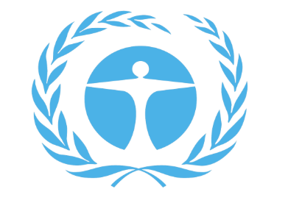
Committee for Environment Protection

Briefing Paper

Zakariya Tanweer
Ali Moussa
HABSMUN 2024

Hi, my name is Zakariya Tanweer, and I will be the head chair of the Committee for environmental protection. I am looking forward to some productive and thought-provoking debate. HabsMUN provides a great opportunity for young people to get a feel for what a real UN conference would be like, but I’m sure you already knew that!
If you have any queries or questions about MUN or the upcoming debate please do not hesitate to ask, just send an email to me, at tan001@habsboys.org.uk
What do you need to do?
As part of being a delegate you are required to produce a position paper. A position paper should be a short summary, (less than a page in length) detailing the policies and procedures of your country that regard to a certain topic. It is always a good idea to write a position paper because it helps to get a better idea of the actions you should take in committee while representing your country, conversely, it’s also kind of awkward to not have one when we ask you to make an opening statement...
In this case the questions are on marine life protection, fast fashion, and solutions for sustainable development. Your position paper should then be emailed to me prior to the debate. As well as the position paper, we ask you to produce a resolution paper on what your country aims to do about the selected issue. Resolution papers, though not obligatory, enhance the whole experience and create a more realistic conference, as to why we urge you to write one. Your resolution papers can be brought with you on the day, but it would be incredibly helpful if you could also send me a copy of your resolutions before the debate.
(We ask that you provide a separate position paper and resolution paper for each topic that we are debating to reduce chances of confusion.)

Questions of debate
The three questions in debate in CEP are:
- The Question of the Protection of Marine Life and Coral Reefs
- The Question of Fast Fashion
- The Question of Nature-based Solutions for Supporting Sustainable Development
Background Information
We are in the middle of a climate crisis. Our climate is changing in unprecedented ways and that’s a culmination of lots of factors, we can’t underestimate fast fashion’s impact on the environment. These commercial trends release 1.2 billion tonnes of CO₂ every year, making up 10% of global emissions. As clothing degrades in landfills it releases methane, a potent greenhouse gas that is 28 times more powerful than carbon dioxide. And that’s just fast fashion…
Globally, oceans are changing. Ocean warming (0.88°C higher in 2011-2020 compared to 1850-1900), oxygen loss (down 3-4% by 2100) and ocean acidification (decreased pH by 30% in 2023 compared to 1700) may be occurring at a speed that may be too fast for species to adapt to the changes – if we don’t implement some serious change. Ergo sustainable development mechanisms.
What are the global impacts of global warming?
Our sea levels are rising due to the melting of glaciers and thermal expansion which are both side effects of our rising global temperature. Between the 1880s and the 1980s global temperature was increasing, on average, by around 0.07 degrees Celsius every year. Since the 1980s, global temperature has been annually increasing by around 0.17 degrees Celsius and 9 out of the 10 hottest years on record have all occurred since 2005. With CO2 emissions still high and a dramatic reduction in them nowhere in sight our global temperature is likely to continue rising and it is not just sea levels that are being affected.
Land aridification is also occurring and is the process in which areas of land are becoming desert, some studies even predicting that as much as thirty percent of the land on earth was at risk of aridification. This could lead to major problems in the areas affected such as malnutrition due to the struggle or complete inability to grow crops on arid land.
When writing your resolution, you should consider:
If your country going to be directly impacted by climate change. Does your country host diverse marine life? Do you export massive amounts of clothing, or propagate a fast fashion culture etc. If so, then how do you plan on mitigating environmental damage?
- Does your Dictator/President/Prime Minister/Parliament believe in the climate crisis?
- Will your country take preventative action?
- What will your national response be targeted towards corporate organisations?
- What should the international response be?

The Question of fast fashion:
Some of the key points of contentions surrounding the issue of fast fashion are:
- Worker rights: Are workers getting the right pay for their work, and if not, is that a result of governments turning a blind eye, or is there a systemic commercial failure within the industry? According to the International Labour Organization (ILO), approximately 75 million people work directly in the garment industry worldwide, many of whom earn below the poverty line and lack basic labour rights. Reports from organizations like the Clean Clothes Campaign highlight instances of unsafe working conditions, low wages, and even child labour in garment factories.
- The environment: Fast fashion leaves a massive carbon-footprint. What can we do to mitigate this, from reducing consumerist attitudes to clothing to perhaps increasing incentives for companies to be more environmentally friendly. Similarly how much wasted clothing ends up in landfills, and could there be initiatives to redistribute the unwanted clothing in the world or perhaps recycle it? The fashion industry is responsible for 10% of global carbon emissions, more than the aviation and maritime shipping industries combined. Additionally, the World Resources Institute estimates that the fashion industry consumes 79 trillion liters of water annually, contributing to water scarcity in many regions.
- General social culture: is fast fashion culture perhaps the result of an over glorification of it on social media? It it's estimated that 85% of discarded textiles end up in landfills, contributing to environmental pollution and resource depletion. To what extent is this a direct result of “ins” and “outs” changing in the fashion world?
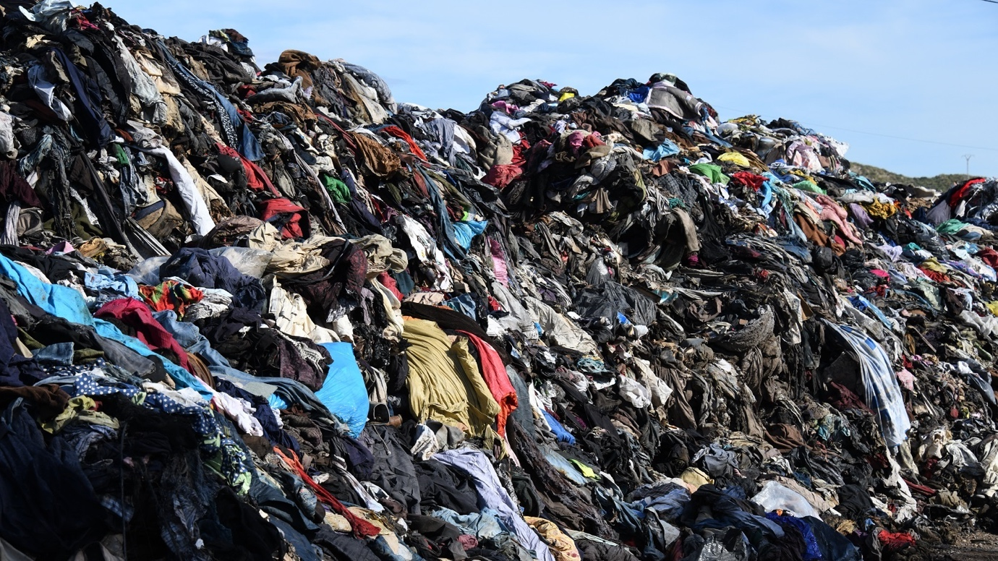
Non-exhaustive list of useful websites
https://www.nationalgeographic.com/environment/global-warming/sea-level-rise
https://www.eea.europa.eu/publications/how-climate-change-impacts#:~:text=Globally%2C%20oceans%20are%20changing.,to%20adapt%20to%20the%20changes.
https://education.nationalgeographic.org/resource/ocean-impacts-climate-change/
https://www.unep.org/news-and-stories/story/environmental-costs-fast-fashion
https://climate.nasa.gov/vital-signs/global-temperature/
https://www.climate.gov/news-features/understanding-climate/climate-change- global-sea-level

This might be of some use as well:
https://www.un.org/en/model-united-nations/drafting-resolutions

Good luck!
(and don’t use chatGTP)

