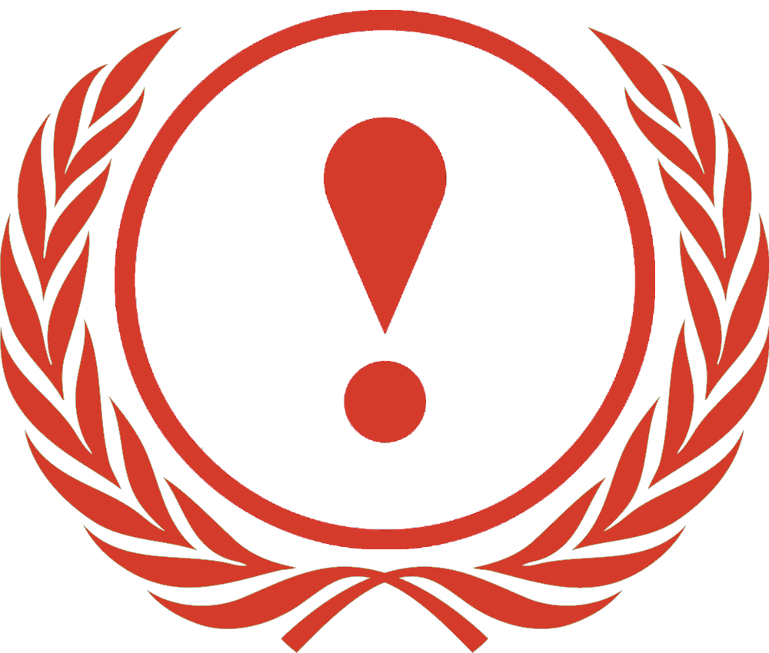

Crisis

Briefing Paper

William Mace
Aarush Bahel
Lucas Nieszporek-Richardson

HABSMUN 2024
Introduction

Hello delegates! We are William, Aarush, and Lucas, the chairs of the Crisis Committee for HABSMUN 2024. We hope you are all looking forward to the conference: it’s a really great opportunity to meet and debate with other young people from across the country. As a delegate, we would like you to prepare a position paper before the conference (a short summary of your country’s policies on the topic you will be debating). The Crisis Committee debates individual clauses, not resolutions, with passed clauses being drafted into a complete resolution in preparation for the General Assembly. Therefore, try to bring a few different clauses (not resolutions) to the conference.
If you have any questions about Crisis procedure, or MUN procedure generally, the HABSMUN website has some useful resources. Alternatively, feel free to send an email to mac110@habsboys.org.uk.
We look forward to seeing you there!

The Question of Yemen

Background Information

In 1962, the Yemen Arab Republic, or North Yemen, was formed following the North Yemen Civil War. In 1967, South Yemen, later officially the People’s Democratic Republic of Yemen, was formed, made up of the former British Protectorate of South Arabia, as well as Aden. In 1972, a short war between the two countries was fought. The Arab League brokered a ceasefire, and it was declared that the two states would eventually be unified. Further fighting occurred in 1979. The South Yemen Civil War, fought between two factions of the Yemeni Socialist Party, which governed South Yemen, lasted between the 13th and 24th January 1986, resulting in between 4,000 and 6,000 people dying, as well as around 60,000 being displaced.
On 22nd May 1990, North Yemen and South Yemen were unified, with the President of North Yemen, Ali Abdallah Saleh, becoming President, with the President of South Yemen, Ali Salim al-Beidh, as Vice-President. In 1994, however, a civil war erupted between northern forces, which supported union and had the backing of states such as the United States, Egypt, Iran, and India, and pro-secession southern forces, which had the support of states such as Saudi Arabia, Iraq, the UAE, and China. Southern Yemen perceived itself as holding inferior status to the north. The war resulted in a victory for the northern forces, the deaths of around 7,000 to 10,000 people, and the purging of socialists from Yemen, with an unknown number of both socialists and separatists being executed.
Ansar Allah, popularly known as the Houthis, is a Zaydi group, which presently controls much of Yemen, including Sanaa, Yemen’s capital city. The group is aligned with Iran but is not considered by analysts to be an Iranian proxy. The Houthi movement is led by Abdul-Malik al-Houthi.
Between 2003 and 2009, a Houthi group in north Yemen, fought six different wars with the forces of Saleh, as well as a war with Saudi Arabia. During the Arab Spring in the early 2010s, which saw protests and uprisings in many Arab countries, there were protests in Yemen which weakened Saleh’s rule. This resulted in the army splitting, as well as al-Qaeda in the Arabian Peninsula (AQAP), seizing eastern territory. Saleh stepped down as President in 2012, being succeeded by Abdrabbuh Mansur Hadi. Between 2013 and 2014, attacks were carried out across Yemen by AQAP, and in September 2014, with the assistance of Saleh, the Houthis seized Sanaa. Hadi resigned, and, on 6th February 2015, the Houthi political leadership dissolved parliament and formed a Revolutionary Committee in order to govern Yemen.
On 21st February, Hadi escaped house arrest in Sanaa and travelled to Aden. Also in February, Hadi rescinded his resignation. On 26th March, it was reported that Hadi had arrived in Riyadh, Saudi Arabia, where he established a government in exile. In March, Saudi Arabia and a coalition led by it intervened, forcing Saleh loyalists and the Houthis from Aden and Marib, which is northeast of Sanaa. This coalition has continued to intervene in the conflict, and is currently made up of Saudi Arabia, the United Arab Emirates, Bahrain, Kuwait, Egypt, Jordan, and Senegal, with Sudan, Qatar, and Morocco as former members. The coalition has the support of the U.S., the United Kingdom, France, and Canada. The coalition has had significant involvement in the conflict; for example, in 2016, the UAE backed local forces fighting against AQAP rule in an AQAP-established mini-state around Mukalla, which resulted in the end of AQAP rule in that area, whilst, also in 2016, the coalition began a partial blockade on Yemen, whilst air raids carried out by the coalition have killed civilians. In 2017, the Houthis fired missiles into Saudi Arabia.
On 2nd December 2017, Saleh officially broke ranks with the Houthis, and advocated for talks with Saudi Arabia to end the war. On 4th December, whilst attempting to escape Sanaa, he was killed by Houthi fighters. In 2020, a truce was announced by the coalition, as a result of the COVID-19 pandemic, but violence continued. In 2022, Houthis fired missiles at the UAE. Also in 2022, Hadi resigned, ceding his power to a Presidential Leadership Council (PLC), which seeks to find a political solution to the civil war. The council is led by Rashad al-Alimi. In 2023, Saudi Arabia and Iran resumed diplomatic relations, providing increased hope for peace in Yemen, and in April, a prisoner exchange, involving Yemeni government forces and rebels, of more than 800 prisoners occurred in Yemen.
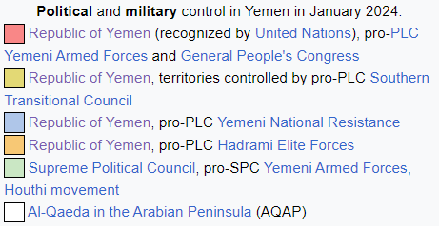
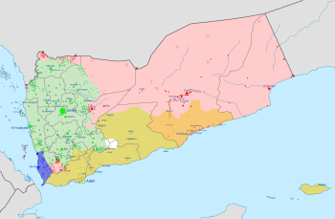

As of January 2024, the Houthis control almost all of North Yemen, including Sanaa. Between 2014 and 2021, over 377,000 people died in Yemen as a result of the conflict, of which over 150,000 died as a result of violence, and over 227,000 died as a result of famine and a lack of healthcare.
The Yemeni civil war has resulted in a severe humanitarian crisis, currently considered by the United Nations to be the worst humanitarian crisis in the world. In 2023, Yemen had a population of approximately 34.4 million people. According to the United Nations Population Fund, in 2023, 21.6 million people in Yemen required humanitarian assistance, and 80% of the population of Yemen was struggling “to put food on the table and access basic services”. Yemen suffered from a severe cholera outbreak between 2016 and 2022, which, as of November 2021, had resulted in over 2.5 million cases. Over 4000 people died in the outbreak, which was largely controlled by the end of 2021 as the result of a vaccination program in which UNICEF and WHO were involved, meaning that there were only 5,676 suspected cases of cholera between January 1st 2021 and March 6th 2021, with 2 deaths. Part of the reason why the outbreak was so severe is because of coalition strikes which damaged healthcare infrastructure. The lack of sanitation in Yemen is also a problem and was a cause of the outbreak’s severity; the United Nations estimated in March 2023 that around 14.5 million people in Yemen were “without access to safe drinking water and reliable sanitation facilities”. Also in March 2023, the UN estimated that 4.5 million people in Yemen were displaced, 17.3 million Yemenis were suffering from “high levels of acute food insecurity”, and 6 million people in Yemen were “on the brink of famine”. Additionally, diseases including diphtheria, measles, and dengue fever are present in Yemen.
The Yemeni civil war remains a point of foreign involvement. The Saudi Arabia-led coalition has the support of the United States, the United Kingdom, France, and Canada. Djibouti, Somalia, and Eritrea have all made their military bases, territorial waters, and airspace available to the coalition. The U.S. and the UK have both sold weapons to the coalition and provided technical assistance.
Since October 2023, the Houthis have been attacking shipping in the Red Sea as part of the Houthis’ support for Hamas in the Israel-Hamas War. Houthi militants have hijacked two ships, whilst Houthi attacks have damaged at least 10 ships. Although, according to the Houthis, their targets are shipping linked to Israel, they have attacked vessels which do not have any apparent link to Israel. The Houthi attacks on shipping have resulted in retaliatory missile strikes on the Houthis by the U.S. and the UK. These attacks are supported by Australia, New Zealand, Canada, the Netherlands, Denmark, and Bahrain. On 15th February 2024, UNCTAD stated that the “Red Sea crisis has reportedly triggered a 40% drop in Suez Canal revenues”.

Previous Action

On 13th December 2018, the Stockholm Agreement was agreed upon by the parties to the conflict in Yemen. The three main components of the Stockholm Agreement are:
- Hudaydah Agreement: in which a ceasefire was agreed upon in “the city of Hodeidah, the ports of Hodeidah, Salif, and Ras Issa and the governorate”.
- Prisoner Exchange Agreement: an agreement for the “exchange prisoners, detainees, missing person, arbitrarily detained and forcibly disappeared persons, and those under house arrest” (according to UNMHA).
- The Taïz Agreement

UNMHA is the UN Mission to Support the Hudaydah Agreement. It is a civil observer mission which began in January 2019.

The components of the Stockholm Agreement, and the degree to which it has been successful, is useful information for delegates to be equipped with.

These resolutions have been previously adopted by the UN Security Council, and can provide a particular insight into previous UN action:

- Resolution 2451 (21st December 2018)
- Resolution 2452 (16th January 2019)
- Resolution 2511 (25th February 2019)
- Resolution 2624 (28th February 2022)
- Resolution 2643 (13th July 2022)
- Resolution 2722 (10th January 2024)

This is not an exhaustive list of UN Security Council resolutions on Yemen, and more resolutions can be found at: https://www.securitycouncilreport.org/un_documents_type/security-council-resolutions/?ctype=Yemen&cbtype=yemen

Questions to Consider

- What steps should be taken by the UN to bring about a peaceful resolution to the conflict in Yemen?

- How can the long-term political stability of Yemen be ensured, in order to reduce the risk of a similar conflict occurring again?

- What role do the UN, member states, and NGOs have to play in combatting the humanitarian crisis in Yemen? What steps should be taken?

- Is the Stockholm Agreement sufficient, or is a new agreement required?

- Should other countries be intervening in the Yemeni conflict, for example through military intervention or arms sales, or should the UN be discouraging/attempting to prevent this?

- How should the UN and its member states deal with the Red Sea crisis, in order to maintain both security and trade?

Further Resources:

https://www.aljazeera.com/news/2023/4/11/a-timeline-of-yemens-slide-into-conflict-and-war

https://www.aljazeera.com/news/2024/1/12/who-are-yemens-houthis-a-basic-guide

https://en.wikipedia.org/wiki/Yemeni_civil_war_(2014%E2%80%93present)

https://www.securitycouncilreport.org/un_documents_type/security-council-resolutions/?ctype=Yemen&cbtype=yemen

https://dppa.un.org/en/mission/unmha-hudaydah-agreement

https://unmha.unmissions.org/stockholm-agreement

https://www.unrefugees.org/news/yemen-crisis-explained/

https://www.unicef.org/yemen/

https://yemen.un.org/en/about/about-the-un

