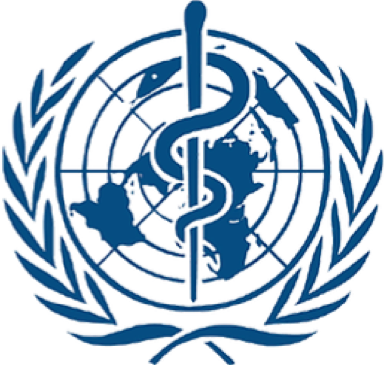

Health
Briefing Paper

Alexander Wasserstein

Sebastian Maltz

HABSMUN 2024

The Question of the Efficacy of Emergency Medical Teams in Response to Natural Disasters and Emergencies

Background
Emergency Medical Teams (EMTs) are defined by the World Health Organization (WHO) as groups of health professionals and supporting staff outside their country of origin, aiming to provide health care specifically to disaster affected populations, and play a crucial role in disaster response. The initiative was established as a result of lessons from the disaster response in Haiti following a 2010 earthquake, and aimed to create a cohesive classification for disaster response teams that were operating under different names and terms, each with various operational capabilities. In the past few decades, there have been several crises that have profoundly affected millions across the globe. The COVID-19 pandemic in particular has inflicted devastating consequences whose extent is immeasurable. They have highlighted the critical need to prioritise the expansion of training and standardised high-quality public health and medical assistance at the national, regional, and global levels for effective emergency preparedness and response.
Key Issues
Increase in natural disasters
Since the 1960s, the world has witnessed a tenfold increase in natural disasters. This has stretched the capacity of EMTs to effectively respond to natural disasters. Over the last 30 years alone, natural disasters have resulted in 800,000 casualties, and 1 billion people have been affected. This raises questions as to whether the other key issues that arise are related to the efficacy of the EMTs or that there are simply not enough of them.
Coordination and Integration
The effective implementation of Emergency Medical Teams (EMTs) encountered a major challenge in the form of inadequate coordination. Factors contributing to this challenge included the inefficient utilisation of EMTs and their supporting resources during ground operations, poor communication with government actors and regional headquarters, limited independence concerning transport and utilities, and a noticeable lack of interaction among the various EMTs involved. The 2010 earthquake in Haiti serves as a prime illustration, where relief efforts were marred by missed opportunities resulting from poor coordination, fragmentation, and a lack of cohesive relief strategies.
National stewardship
National and local governments are vital in coordinating early relief efforts. This is shown through a case study on the aftermath of typhoon Haiyan in the Philippines: despite the arrival of 108 Emergency Medical Teams (EMTs), none were operational within the first 72 hours, taking an average of 82 hours to become fully functional. The initial 72 hours following a natural disaster play a pivotal role in emergency response, and the management of this timeframe can significantly influence subsequent outcomes, and therefore it is recommended that delegates mention that countries should have a national emergency plan in their resolution. In the case of the Philippines, obstacles to achieving operational capacity included the absence of internet availability, inadequate debriefing for new arrivals, insufficient self-sufficiency among EMTs, and a lack of appropriate technical equipment, as well as transportation.
Legal Frameworks
In 2021, the UN revised their classification and minimum standards for EMTs, which we have linked in the further reading section of the paper. We would highly recommend that you use this to advise your resolution, as it provides comprehensive information about minimum standards both operationally and for clinical care, as well as the guiding principles of EMTs and some useful information surrounding them. Whilst there shouldn’t be anything here that will outright prevent you from improving their efficacy, be careful not to explicitly do anything that conflicts with the document.
We won’t have covered every point here, so find below some useful further reading:
- 9789240029330-eng.pdf (who.int)
- The role of emergency medical teams in disaster response: a summary of the literature | Natural Hazards (springer.com)
- New WHO strategy aims to strengthen rapid response to health emergencies | UN News
General tips for resolution writing can be found on the briefing paper for The Question of Sanitation in Sub-Saharan Africa and on habsmun.com. Good luck!

