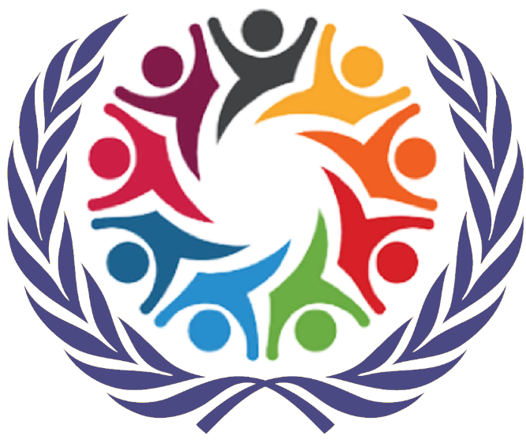

SOCHUM
Social, Humanitarian & Cultural Issues
Briefing Paper

Arjan Dhanjal
Shivam Patel
Neeam Radia
Rishikesh Trivedi

HABSMUN 2024

The Question of the War on Drugs

Background

Drugs are defined in the Merriam-Webster dictionary as ‘a substance used as a medication or in the preparation of medication’, however the ‘war on drugs’ is more focused on the illicit use of drugs and their definition as ‘something and often an illegal substance that causes addiction, or a marked change in consciousness’ (Merriam-webster.com, 2024). Drugs have several effects on society and people, including increased crime rates, violence, and strain on public healthcare systems. The war on drugs has been active, with governments and international bodies painstakingly trying to bust the drug trade, with a view to discourage the production, distribution, and consumption of narcotics. The term ‘war on drugs’ was popularised by the media after Nixon declared drug abuse public enemy number one in a press conference given on June 17, 1971. In 1997, the UN established the United Nations Office on Drugs and Crime (UNODC) – it is ‘a global leader in the fight against illicit drugs and international crime, in addition to being responsible for implementing the United Nations lead programme on terrorism’.

Key Definitions

Narcotics – A drug or other substance that affects mood or behaviour and is consumed for non-medical purposes, especially one sold illegally.

Drug Trafficking – The production, transportation, and sale of illicit drugs, often involving organised criminal groups.

Illicit drugs – Substances that are illegal to produce, sell, or use, such as heroin, cocaine, and methamphetamine.

Key Issues

Size of the drug issue

- Drug trafficking is a worldwide problem, with 296 million people using drugs in 2021, a 23% increase over 10 years (UNODC WDR 2023).
- Global drug cultivation has kept increasing, with a 35% increase in cultivation of the coca bush between 2020 and 2021, and a 28% increase in cultivation of the opium poppy between 2021 and 2022.
- Overall global production is increasing too – with a 16% increase in pure cocaine production between 2020 and 2021.
- The production and trafficking of drugs generate billions of dollars in revenue each year, with estimates ranging from $426 billion to $652 billion per year.

The drug trade is one of the largest illicit markets in the world and it is a completely global market. Drug production mostly occurs in Latin America, Asia and Africa, with the majority of the world’s cocaine and heroin originating from Colombia and Afghanistan, respectively. The globality of the drug trade and drug usage is one of the key factors making drugs such a prevalent issue which is so difficult to fight. It is nearly impossible for the war on drugs to be successful without complete international cooperation and effort.

Social effects

With the war on drugs being so greatly publicised and talked about, drug use and addiction often become greatly stigmatised in society, leading to discrimination against individuals who are struggling with substance abuse issues. This can exacerbate their social isolation and hinder their ability to seek help.

The enforcement of drug laws has disproportionately affected marginalised communities, including people of colour and low-income individuals. This contributes to systemic inequalities and exacerbates social divisions.

The criminalisation of drugs and the exclusion of those involved in the drug trade leads to violence and organised crime, leading to increased levels of violence in affected communities. This not only threatens public safety but also undermines social cohesion and trust.

The militarized approach to combating drug trafficking has fuelled violence and instability, particularly in regions where drug cartels operate with impunity. The pursuit of drug interdiction through military and law enforcement measures has led to armed conflict, human rights abuses, and widespread violence, undermining social cohesion, and endangering civilian populations.

Economic Impact

The war on drugs has significant economic implications, both domestically and internationally. This includes expenditures on law enforcement, incarceration, and border security, as well as the economic costs of drug-related crime and healthcare expenses. Additionally, in drug-producing regions, the illicit drug trade can have complex economic effects on local economies, influencing employment, investment, and development.

International Relations and Diplomacy

The global nature of the drug trade necessitates international cooperation and diplomacy in efforts to combat drug trafficking. However, the enforcement of drug policies can sometimes strain diplomatic relations between countries, particularly when there are disagreements over approaches to drug control, drug interdiction operations, or the use of military force in drug-producing regions.

Impact on Governance and State Institutions

The influence of drug cartels and organized crime groups can undermine governance and state institutions, particularly in countries where corruption is prevalent. This includes the infiltration of law enforcement agencies, political corruption, and the erosion of public trust in government institutions, posing significant challenges to the rule of law and democratic governance.

Timeline & Previous Action

Early 20th Century: The war on drugs had its start in the early 20th century when nations like the US started passing laws banning certain substances, such the Harrison Narcotics Tax Act of 1914, which tried to control and limit the distribution and sale of specific drugs.

1960s–1970s: With growing worries about drug usage and the rise of illegal drug markets, the 1960s and 1970s saw the start of the modern era of the war on drugs. When President Richard Nixon formally proclaimed a "war on drugs" in the US in 1971, it signalled the start of a string of harsh measures meant to stop drug usage and trafficking.

1980s: During this time, the war on drugs grew more intense, especially in the US with the passage of stringent anti-drug legislation such as the Anti-Drug Abuse Act of 1986 and the Anti-Drug Abuse Act of 1988. These laws imposed harsh penalties for drug offenses and led to a dramatic increase in incarceration rates, especially among minority communities.

1990s: In the 1990s, the war on drugs continued with a focus on both domestic and international efforts to combat drug trafficking and production. The United States implemented initiatives like the Plan Colombia, which aimed to eradicate coca cultivation in Colombia, a major source of cocaine production. United Nations Office on Drugs and Crime (UNODC) formed in 1997, a result of the merging of the United Nations Centre for International Crime Prevention and the United Nations International Drug Control Programme.

2000s: The 2000s saw ongoing efforts to combat drug trafficking and drug abuse, but there was also a growing recognition of the limitations and unintended consequences of the war on drugs. Some countries began exploring alternative approaches to drug policy, such as harm reduction and drug decriminalization. Dissent in America against the policy grew greatly during the early 2000s, partially due to work by the American Civil Liberties Union (ACLU) to make clear the racial prejudice involved in the war on drugs with up to 14 times the amount of African American citizens being sent to prison for drug-related crimes when compared to the number of white citizens incarcerated for the same offences. The ACLU went so far as to conclude that the cumulative effect of the war on drugs amounted to ‘the US apartheid, the new Jim Crow.’

2010s-Present: In recent years, there has been a significant shift in the approach to drug policy in some countries. Several U.S. states have legalized cannabis for recreational and/or medical use, and there has been a growing emphasis on treating drug abuse as a public health issue rather than solely a criminal justice issue. Internationally, there have been calls for drug policy reform and a revaluation of the effectiveness of traditional enforcement-focused approaches. Usage of the term ‘war on drugs’ was reduced during the Obama administration, to escape from the troubled past of the policy and its divisive effects throughout the country and the world.

Questions to Consider

- What are the primary objectives of the war on drugs, and how effective have current strategies been in achieving these objectives?

- What are the social, economic, and public health consequences of the war on drugs, both domestically and internationally?

- How do drug policies and enforcement measures impact human rights, particularly in terms of due process, freedom from arbitrary detention, and protection against torture and abuse?

- What role should the United Nations and other international organizations play in coordinating global efforts to combat drug trafficking and abuse?

- How can the international community address the root causes of drug production, trafficking, and consumption, particularly in regions where these activities are prevalent?

- What are the ethical implications of current drug control policies, particularly in terms of their impact on marginalized communities, public health outcomes, and individual liberties?

Useful Links

UNODC WDR 2023

War on Drugs - Wikipedia

War on Drugs - Britannica

UNODC

