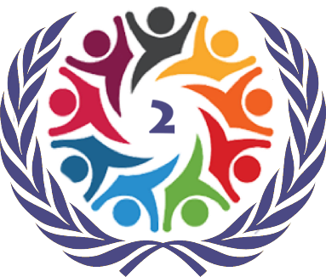

SOCHUM 2

The Chagos Islands

Briefing Paper

Burhan Yurtseven
HABSMUN 2024

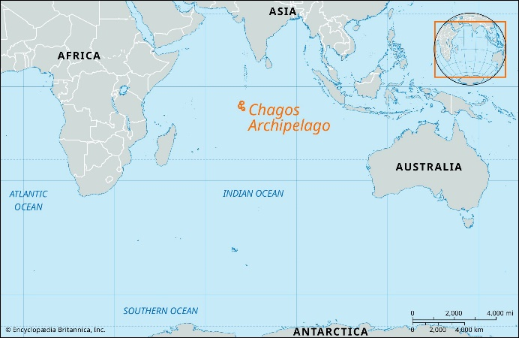
The Background Information
The Chagos Archipelago, a remote group of islands in the Indian Ocean, has been at the center of a protracted legal and political dispute between the United Kingdom and Mauritius. The origins of the conflict can be traced back to the decolonization process in the mid-20th century.
In 1965, three years prior to Mauritius gaining independence from the UK, the Chagos Archipelago was excised from the territory of Mauritius by the British government. This action was taken to establish the British Indian Ocean Territory (BIOT), which allowed the UK to lease the strategically located island of Diego Garcia to the United States for the construction of a major military base.
The forced depopulation of the Chagos Archipelago occurred between 1967 and 1973, with the entire Chagossian population, known as the Ilois, being expelled from the islands and prevented from returning. Many were displaced to Mauritius and the Seychelles, facing significant challenges in resettlement and preserving their unique culture and way of life.
Mauritius has consistently challenged the legality of the UK's actions, arguing that the detachment of the Chagos Archipelago from its territory violated international law and the right to self-determination. In 2019, the International Court of Justice (ICJ) issued an advisory opinion affirming that the decolonization of Mauritius was not lawfully completed due to the excision of the Chagos Archipelago and that the UK's continued administration of the islands constituted a "wrongful act."
The ICJ's opinion, while non-binding, carried significant moral and legal weight, putting pressure on the UK to engage in negotiations with Mauritius regarding the eventual transfer of sovereignty over the Chagos Archipelago. However, the UK's position has been complicated by its long-standing agreement with the United States, which maintains a strategically important military base on Diego Garcia.
In November 2022, the UK government announced its intention to initiate negotiations with Mauritius and the Chagossian community, acknowledging the need to address the long-standing dispute. This development raised hopes for a potential resolution that could involve the eventual return of the Chagossians to their homeland, subject to certain conditions and arrangements.
The Chagos Archipelago dispute has implications beyond the specific territorial claims, as it touches upon broader issues of decolonization, human rights, and the rights of indigenous populations
Resolving the dispute will require careful consideration of the complex legal, political, and human rights dimensions involved.

Points to consider
Is there potential for a solution to this problem?
- Analyse the historical background and root causes of the Chagos Archipelago dispute, including the forcible eviction of the Chagossian people by the UK and the establishment of the British Indian Ocean Territory.
- Examine the legal implications of the International Court of Justice's advisory opinion on the Chagos Archipelago, which ruled that the UK's continued administration of the islands constitutes a 'wrongful act of a continuing character'.
- Explore the feasibility of various proposed solutions, such as the complete decolonisation of the Chagos Archipelago, the transfer of sovereignty to Mauritius, or the establishment of a shared sovereignty arrangement.
- Consider the potential challenges and obstacles to implementing a solution, including geopolitical tensions, military interests, and environmental concerns.

Is there a need for a clear legislative response on the issue of decolonisation?
- Analyse the existing international legal framework pertaining to decolonisation, including the relevant United Nations resolutions and the principles of self-determination and territorial integrity.
- Assess the effectiveness of the current legal mechanisms in addressing cases of prolonged colonial rule and the dispossession of indigenous populations.
- Examine the role of the United Nations and other international organisations in facilitating the decolonisation process and ensuring compliance with international law.
- Consider the potential implications of a clear legislative response, such as setting precedents for other territorial disputes and promoting accountability for human rights violations.
How can we repatriate Chagos Islanders effectively?
- Examine the current living conditions and socio-economic status of the displaced Chagossian communities in Mauritius, the UK, and other countries.
- Analyse the feasibility of resettlement plans, considering factors such as infrastructure development, access to resources, and the preservation of Chagossian culture and identity.
- Consider the environmental impact of resettlement on the fragile ecosystems of the Chagos Archipelago and potential mitigation strategies.
How do we prevent this from occurring again?
- Analyse the historical patterns and root causes of forced displacement and colonial exploitation, drawing lessons from the Chagos Archipelago case and other similar situations.
- Examine the existing international legal frameworks and mechanisms for protecting the rights of indigenous populations and preventing human rights violations.
- Explore potential reforms to strengthen accountability measures and enforce compliance with international law, such as enhancing the role of the International Court of Justice and promoting transparent and inclusive decision-making processes.
- Consider the role of international organisations, civil society, and public awareness in promoting decolonisation and preventing future instances of forced displacement.
Do you think that the intervention of the UK will be successful in providing a solution to this problem?
- Analyse the UK's current position on the Chagos Archipelago dispute, considering its legal obligations, geopolitical interests, and historical ties to the region.
- Examine the UK's proposed solutions or initiatives, if any, and their potential effectiveness in addressing the concerns of all stakeholders, including the Chagossian people and Mauritius.
- Assess the UK's willingness to engage in meaningful dialogue and negotiations, and its commitment to upholding international law and human rights principles.
- Consider the potential implications of the UK's intervention on its international reputation and relations with other countries, particularly in the context of its post-Brexit foreign policy.

