Committee: DISEC

Topic: The Question of Measures to Reduce Paramilitary Groups in Latin America

Chair: Jamie Hu

School: Haberdashers’ Elstree Schools

Introduction:

Paramilitary forces in Latin America have, for a long time now, posed a threat to regional stability through the promotion of cyclical violence, undermining state authority, and exacerbating social inequalities. To achieve their goals, these groups oftentimes operate outside the law by engaging in illicit activities, including drug trafficking, human rights abuses, and targeted killings. Despite the various efforts by states and international organizations, the proliferation of paramilitary forces remains one of the harshest challenges.  
  
Key Term Definition:  
  
Paramilitary Group:  
A semi-organized, non-state armed force that, at times, parallels military organizations but operates outside the formal legal and constitutional parameters. It can function to further state aims, serve as a private militia, or commit crime.  
The formal process of disarmament, demobilization, and reintegration of armed groups.  
  
Reintegration:  
Programs assisting former combatants with civilian life, for instance, by funding education, offering jobs, or psychological treatment.  
  
Transitional Justice:  
Mechanisms to deal with past human rights abuses, including truth commissions, amnesties, or prosecutions, with the aim of promoting reconciliation in post-conflict societies.  
  
Human Rights Abuses:  
Violations of fundamental human rights, often perpetrated by paramilitary groups, including extrajudicial killings, forced disappearances, and torture.

General Overview:

Similar to anywhere else in the world, Latin American paramilitary groups originally started from a combination of historical, sociopolitical, and economic factors: weak state institutions, civil wars, organized crime, amongst others. Many groups initially formed during the Cold War as counterinsurgency forces, funded by governments or elite landowners to fight against communist guerillas. Over time, many of them evolved into criminal organizations with ties to drug trafficking and corruption.  
  
The impacts of paramilitary activity are profound:

Humanitarian Crisis - The worst atrocities include mass displacement, killings, and routine human rights abuses perpetrated by the paramilitaries.  
Undermined Governance - Such groups engender a lack of confidence in governments because they create islands of illegality.  
Economic Burden - Illegal practices by the paramilitaries distort economies on the local level and discourage outside investment.

Any resolution will be truly multi-dimensional, necessitating the addressing of root causes relative to paramilitary formation, coupled with network dismantling.  
  
Key Players:

Republic of Colombia:  
Of the countries in Latin America, Colombia has seen some of the most pervasive paramilitary activity. Groups such as the United Self-Defense Forces of Colombia (AUC) played an integral role in the nation's civil war, regularly attacking leftist guerillas and civilians. Despite efforts at demobilization, splinter groups-known as Bacrims, or criminal bands-remain active.

Currently, there are 2 main paramilitary groups in Columbia as we speak: the Revolutionary Armed Forces of Colombia (FARC) and the National Liberation Army (ELN).

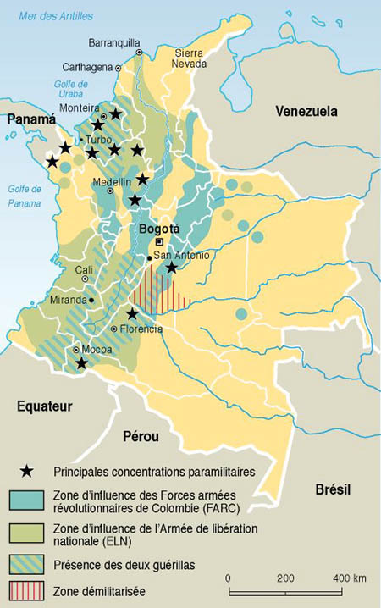  
  
Mexico:  
In Mexico, the presence of paramilitary forces often overlaps with powerful drug cartels. Groups such as Los Zetas were formed by military deserters who built an advanced network of paramilitary cartels.  
  
Brazil:  
In Brazil, paramilitary militias have taken control over urban areas, providing security for residents in exchange for money while dictating drug trafficking and other organized crime.  
  
Guatemala and El Salvador:  
During the civil wars in the latter half of the 20th century, paramilitary groups in Guatemala and El Salvador served as government-aligned death squads. Today, their memory endures as gangs such as the MS-13 have taken the place of demobilized militias.  
  
International Organizations:  
Organizations such as the United Nations, the Organization of American States, and human rights groups are diligently working against paramilitary violence through peacebuilding missions, monitoring, and policy recommendations.

The United States of America have been one of the most active countries in intervening in Latin America, shown in the map below:

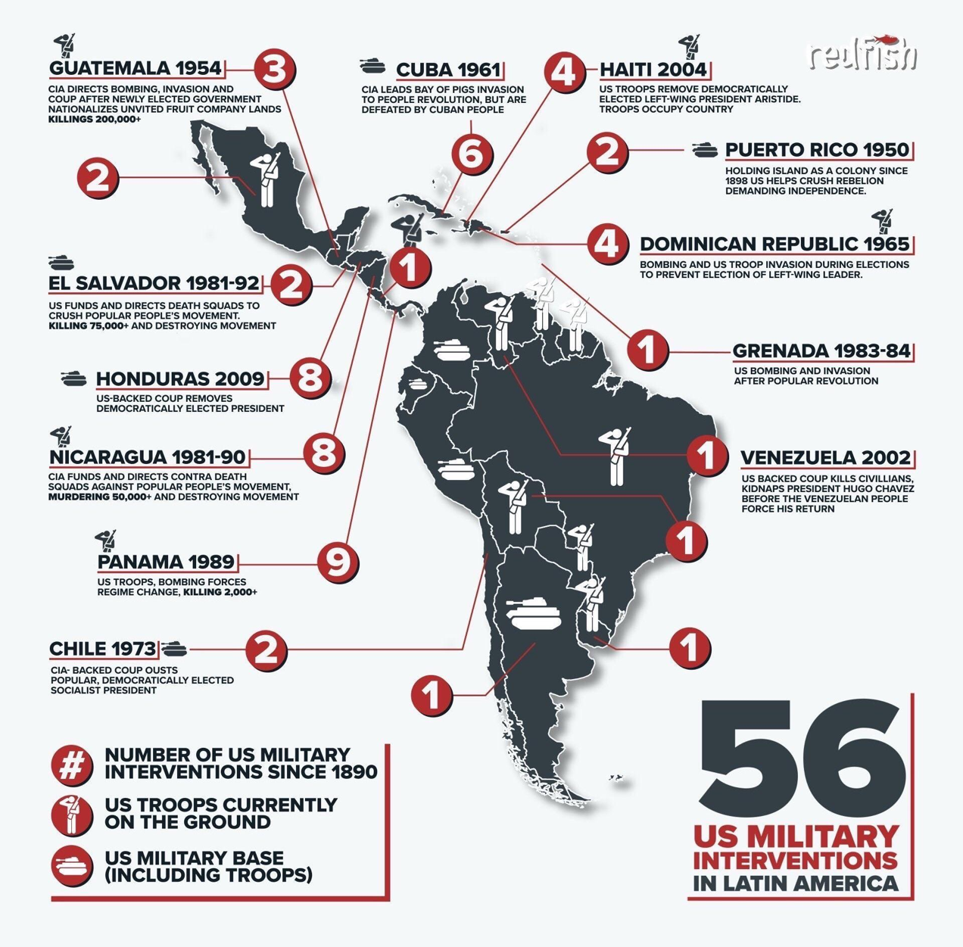  
  
Timeline of Key Events:

#### 1920s–1930s: Early Roots

* 1920s-1930s: Formation of Early Paramilitary Groups
  + Government-backed militias emerge in response to labor movements, indigenous uprisings, and foreign influence in countries like Mexico and Colombia.
  + Key groups: Convivir (Colombia, early informal beginnings).

#### 1940s–1960s: Cold War Tensions

* 1940s-1950s: Anti-Communist Militias
  + Governments form paramilitary groups to counter perceived communist threats.
  + Example: Civil Defense Patrols in Guatemala.
* 1960s: Emergence of Leftist Guerrillas and Right-Wing Paramilitaries
  + As leftist guerrilla groups rise, right-wing paramilitaries are formed with tacit or overt government support to suppress opposition.
  + Example: United Self-Defense Forces of Colombia (Autodefensas Unidas de Colombia, AUC).

#### 1970s: Height of Paramilitary Activity

* 1970s: Operation Condor
  + Coordinated efforts among South American dictatorships (e.g., Chile, Argentina, Uruguay) to suppress left-wing insurgents, often through paramilitary proxies.
  + Death squads like La Mano Blanca in Guatemala become prominent.
* Efforts to Address Paramilitaries Begin
  + International human rights organizations start documenting abuses, pressuring governments.

#### 1980s: International Condemnation

* 1980s: Escalation of Violence
  + Paramilitaries in El Salvador (e.g., ARENA-backed death squads) and Colombia grow in size and brutality.
  + 1982: Guatemala’s Ríos Montt regime formalizes paramilitary groups into Civil Self-Defense Patrols.
  + International organizations like Amnesty International bring attention to paramilitary atrocities.
* 1989: Peace Negotiations Begin in El Salvador
  + Initial discussions about disbanding death squads as part of broader peace efforts.

#### 1990s: Peace Processes and Demobilization

* 1990s: Peace Agreements and Demobilization
  + 1992: El Salvador’s Chapultepec Peace Accords call for the dissolution of paramilitary groups and the establishment of new civilian police forces.
  + 1996: Guatemala’s Peace Accords lead to the disbanding of Civil Defense Patrols.
* Mid-1990s: Emergence of New Paramilitary Structures
  + Despite peace agreements, former paramilitary members often join organized crime syndicates or private security.

#### 2000s: Continued Challenges

* 2000s: Focus on Colombia
  + 2003-2006: Colombian government negotiates with the AUC for demobilization; partial successes but criticism over reintegration of members into criminal enterprises.
* Efforts by international and regional organizations, including the Organization of American States (OAS), intensify to curb paramilitary resurgence.

#### 2010s–Present: New Dynamics

* 2010s: Shift to Organized Crime
  + Many former paramilitary groups evolve into drug trafficking organizations and criminal syndicates.
  + Governments launch multi-faceted efforts combining military action, socio-economic reforms, and international cooperation.
* 2016: Colombian Peace Accords with FARC include measures to dismantle paramilitary influence but face implementation challenges.

#### 2020s: Ongoing Struggles

* Governments continue to combat the remnants of paramilitary groups, often intertwined with organized crime.
* Regional collaboration, economic development programs, and international monitoring are prioritized.

Previous Attempts to Resolve the Issue:

Demobilization Programs: Efforts like the demobilization of Colombia's AUC aimed at disarmament and reintegration of the fighters. Due to a lack of reintegration mechanisms, while large-scale violence was greatly reduced, new criminal groups surfaced.  
  
Peace Agreements: Agreements in countries like Guatemala in 1996 and Colombia in 2016 sought to tackle the root causes of conflict, including land reform and political representation. However, weak law enforcement and corruption weakened these processes.  
  
International Sanctions: The U.S. and European Union have imposed sanctions on individuals and entities linked to paramilitary groups. While impactful, these measures have limited reach in decentralized operations.  
  
Judicial Measures: Trials like the Colombian Justice and Peace Law allowed paramilitaries to confess crimes in exchange for reduced sentences. This transitional justice mechanism has been criticized for enabling impunity.  
  
Possible Solutions:

1. Strengthening State Capacity  
It is necessary to strengthen the states' ability to enforce the rule of law in areas controlled by paramilitaries, including:

- Training and reequipping local police forces  
- Anti-corruption mechanisms that would engender public confidence in the forces

2. Socioeconomic Development  
Poverty and inequality are some of the factors that drive young people into the rank and file of these paramilitaries. The strategies include:  
  
- Job creation programs in conflict zones  
- Investing in education and vocational training among the youth

3. Reintegration Programs  
Improved reintegration for former fighters should focus on:  
  
- Long-term employment opportunities.  
- Psychological counseling to deal with trauma.

4. International Cooperation  
Regional cooperation is indispensable in combating transnational networks. This may be achieved by:  
  
- Improved intelligence-sharing mechanisms.  
- Multilateral initiatives on combating illicit financial flows associated with paramilitary structures.

5. Transitional Justice Frameworks  
Thorough going into truths and reconciliation processes can redress injustices with accountability of perpetrators. Relevant experiences from South Africa and Rwanda provide useful lessons.  
  
Bibliography:  
  
Human Rights Watch: "Paramilitaries in Latin America"-in-depth reports regarding human rights abuses and the sociopolitical consequences of these paramilitary groups.

United Nations Office on Drugs and Crime (UNODC): Publications regarding organized crime and its link to paramilitary activities.

Amnesty International: Reports on civilian impacts and governmental responses to paramilitary violence.

The World Bank: Data on socioeconomic disparities in Latin America contextualize the emergence of paramilitaries.

Colombian Truth Commission: Light on the AUC demobilization process and its aftermath.

Gutiérrez Sanín, F. & Barón, M. (2011). "Paramilitarism in Colombia: Criminalized Organizations and New State Agendas." International Journal on Violence.

Orozco, J. (2018). The Role of Paramilitaries in Latin America's Conflict History. Cambridge University Press.

United Nations Development Programme (UNDP). 2021. Post-Conflict Reintegration Strategies: Lessons from Colombia and Beyond.