HABSMUN 2020
DISEC briefing Paper

The Question of the Militarisation of Space

Background
The militarisation of space, sometimes also known as ‘the weaponization of space’, is the placing of weaponry, defence technology – such as imaging or communication satellites - or military equipment by a state into outer space. It also covers any further development or advancement of said objects whilst they are held within space, mainly concerning the expansion of these forces. Several states, including the USA, China and India, have now assembled what they call a ‘space force’, with aims of improving both their global power status, as well as their fighting capabilities in orbit.

The placement of military technology began during the Cold War, when the USA and the USSR were competing for global superiority, to spread their own personal ideals in a conflict between Capitalism and Communism which spanned from 1947 to 1991. In this war, vast research and GDP spending went into expansion of conventional forces in preparation of conflict breaking out. This included the aim of sending weaponry into space, thus beginning ‘the Space Race’. The first artificial satellite, ‘Sputnik 1’, was launched into space by the USSR on 4th October 1957, which was marked as the first act of militarising space. From there, many other states developed their own space military programmes, mainly in the form of data collecting satellites, so as to prevent one power becoming more dominant than its competitors.

Since then, the contest to hold the supremacy within space has increased, alongside the threat of ‘Space War’ or ‘Space Warfare’. As contemporary international relations become more strained, particularly with a more prominent divide between the East and the West, the want for military advantage also becomes more important.

Key Issues
The issues lie in the increased threat of ‘Space War’, as contemporary political leaders speak out about their aims to militarise and weaponize places in orbit. A conflict in space would most likely expand onto Earth in addition, bringing our population closer to a much larger war. There is currently no legally binding document relating to restrictions on the militarisation of space and so those who believe it should remain a common territory among all states struggle to have an impact on the increasing technology already situated there.

What has already happened?
The Conference of Disarmament have met many times to discuss the militarisation of space and whether its justification is enough for no action to be taken against it. The most supported draft treaty was submitted by China and the Russian Federation in both 2008 and 2014 on the prevention of an arms race in outer space. This has been endorsed by many states, but its main concern lies on the issue of safety, as well as the continuation of stockpiling deployable weapons. Delegates have previously discussed the need for a definition of ‘space weaponry’, to determine between weapons of mass destruction as opposed to imaging satellites. It is important to remember the differing uses for these technologies, in order to ascertain the intent behind their stationing, whether that is a case of security, or surveying geographical information for major changes which may pose a threat.

What are the aims?
Delegates are hoping to create a legally binding document which specifies whether different areas of space should be selected to be under a state’s jurisdiction, and so be claimed as their ‘territory’. Leading on from this delegation of space, the question of whether militarisation should occur to any extent comes into play – states are now disputing, much as they do with nuclear weapons, the proliferation of technology and weapons in space as a whole. States are now aiming to clarify the future of our international climate, which remains at stake until clear guidelines have been formulated.
Those who have already been involved in the militarisation of space seem eager to continue their dominance in a new technological area, with, as it seems, the majority of others left considering the safety of their population as result.

Timeline of Key Events
- August 1957: The USSR successfully tested their first intercontinental ballistic missile (ICBM)
- 4th October 1957: The USSR launched their first artificial satellite, ‘Sputnik 1’, into space, beginning ‘the Space Race’
- 31st January 1958: The USA launched their first satellite, ‘Explorer 1’, into space as a response to the USSR
- 1958: The USSR launched the first ICBM into space
- 1959: The USA again responded with their own ICBM launch
- 27th January 1967: The Outer Space Treaty was signed
- 1991: The end of the Cold War marked the end of the initial ‘Space Race’
- January 2001: UN A/RES/53/32 on the prevention of an arms race in space was debated by the General Assembly
- 9th August 2019: Mike Pence released his plans for the creation of a ‘Space Force’ by 2020 during a speech
Relevant Stakeholders
Russian Federation, USA, China, India, UK, Germany
Questions to consider
Should there be a ban on all technology or militarisation of space?
Should states have a sovereign claim over particular areas in space?
What are the consequences of a ‘Space War’ breaking out?

The Question of the One-Belt-One-Road Initiative
Background
The One Belt One Road Initiative, or as it is commonly known in English, the Belt and Road initiative, is the President of China, Xi Jinping’s signature, monumental policy. It’s effectively a project that aims to re-establish the Silk Road trade routes linking Asia and Europe. By investing a total of US$900bn into roads, pipelines, ports, railways and other infrastructure in 65 foreign countries along these routes, China is hoping to solidify their status as the new global superpower by setting up and keeping control over vast trading routes. The initiative is the biggest foreign investment strategy in global history by any one country, and if successful, could very possibly push China into the most powerful global position that any country has ever seen, as the initiative spans 4.4 billion people and a third of the entire world’s GDP.
However, many analysts have begun to view the initiative as a trillion-dollar mistake, on China’s part. The Chinese Communist Party has fundamentally bought into the notion that nuanced and complex geopolitical crises and issues can be solved to be tipped in their favour by simply spending huge amounts of money to attempt to strongarm control over their ideal global trading routes. Since the 1990’s, the Chinese Communist Party has promoted the purpose of “common destiny”, and Xi has been playing the Belt and Road initiative to these ideas, by espousing rhetoric about the initiative being for the good of the populations of the developing countries which the project encompasses. While it may be true that the BRI could well have a positive impact on aspects of the infrastructure of these countries, it is a mistake to assume that this is the only aim of China’s – and in fairness, not many countries would undertake a trillion dollar trading route project without thinking of themselves first.
Key Issues
Where is the BRI going to be carried out?
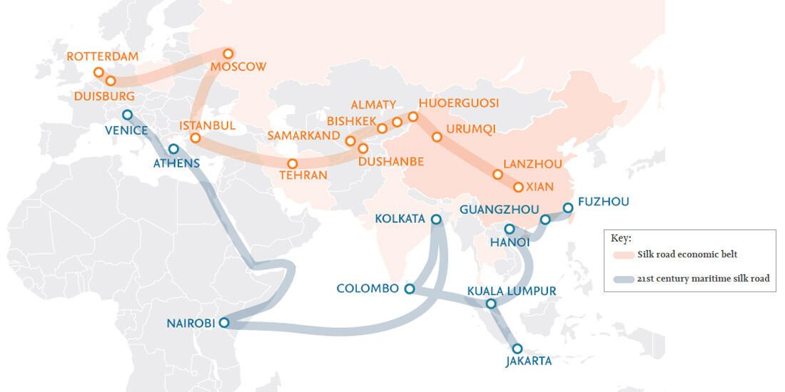

The initiative is being undertaken via two routes; one over land and one across water. The route over land is a series of six main economic corridors, moving from Xian, China through the Middle East all the way up to Rotterdam in The Netherlands. The maritime routes make up the second part of the “belt”, and are generally called the

What has already happened?

The BRI has been around for 5 years, and while the final results are yet to be seen, the projects in South and Southeast Asia, which have been described by Chinese politicians as the “main axis” of the plan, have yet to produce returns for its investors, and little reward has been reaped politically. Granted, many analysts believe that the project isn’t actually meant to produce returns on investments, but rather it was born out of a geopolitical necessity. Regardless, the vast majority of existing BRI developments in South Asia are not yet financially promising.

What are the aims?

As already outlined, the Belt and Road Initiative is Xi Jinping’s vision of an expansive network of transport routes, energy pipelines and railways to expand the use of Chinese currency (the Renminbi), gain control over trade routes running through developing countries (although this is derived, mainly by US analysts and spokesmen for the Administration), and to “break the bottleneck in Asian connectivity”. China also wants to construct 50 special economic zones, to take after the current Shenzhen special economic zone, launched in 1980 under Deng Xiaoping. The largest project to take place is the China-Pakistan Economic Corridor, which is set to cost approximately $68 billion.
While the project may look bleak in terms of direct financial returns for investors, one of the aims of the BRI is to open new markets for China’s consumer goods and its industrial capacity, which is in excess, even with the status as the major manufacturing industry in the world that’s been solidified in the last 30 years.
XI generally sees the BRI as a way to push back against the US’s “Pivot to Asia”, and furthermore as a way to diversify Chinese exports, boost incomes and consumption as well as create investment opportunities for Chinese firms in the future.

Timeline of Key Events
- 2013: Xi Jinping proposes the BRI in Kazakhstan and Indonesia
- November 2014: China announces US$40 billion will go into a fund to support the initiative
- December 2015: China starts the Asian Infrastructure Investment Bank, to formally establish the funds for the initiative
- May 2017: the first BRI forum is held in Beijing, attended by heads of states in 29 countries, and participants from over 140 countries
- October 2017: the Constitution of the CCP was amended to include pursuing the initiative
- August 2018: the number of China- Europe freight trains reached 10,000
Relevant Stakeholders
China, USA, India, Pakistan, Russia, and any country in which investment is to be undertaken, or has already been undertaken.

Questions to consider
To what extent does the initiative present a danger to international security?
How should existing superpowers other than China react to what the US sees as a grab at global supremacy?
How significant is the potential of the BRI to cause damage or major political upset to the populations and economies of the countries, and indeed continents, through which it spans, and to countries through which it doesn’t?

The Question of Election Security

Background
An election is defined as a formal group decision-making process by which a nation chooses an individual to hold public office. Elections form a key part of our political processes and have a large impact on shaping the futures of our societies including, political transitions, implementation of peace agreements and consolidation of democracy. The United Nations plays a major role in providing international assistance to these important processes of change. The UN has ratified the standards of election procedure within Article 21 (3) of United Nations Declaration of Human Rights which states that ‘the will of the people shall be the basis of the authority of government; this will shall be expressed in periodic and genuine elections which shall be by universal and equal suffrage and shall be held by secret vote or by equivalent free voting procedures’. These commitments were further developed in Article 25 of the UN International Covenant for Civil and Political Rights.

Currently the United Nations electoral assistance is provided only at the specific request of the Member State concerned, or based on a mandate from the Security Council or General Assembly. Before assistance is agreed and provided, the United Nations assesses the needs of the Member State to ensure that the assistance is tailored to the specific needs of the country or situation. As the General Assembly has reaffirmed on many occasions, United Nations assistance should be carried out in an objective, impartial, neutral and independent manner, with due respect for sovereignty, while recognising that the responsibility for organising elections lies with Member States. More than 100 countries have requested and have received United Nations electoral assistance since 1991.

Election security refers to the protection of elections and voting infrastructure from infiltration or tampering by cyberattacks. Since elections are such a vital part of democracy as we know it we have a duty to provide the civilians with the international standards of being ‘free and fair’. Elections have been the usual mechanisms by which modern representative democracy has operated since the 17th century defining just how important it is to represent and maintain the civilians political decisions.
Currently the three main strategies for the prevention of electoral fraud in society are: auditing the election process, deterrence through consistent and effective prosecution; and cultivation of mores that discourage corruption. Some of the main fraud prevention tactics can be summarised as secrecy and openness. The secret ballot prevents many kinds of intimidation and vote selling, while transparency at all other levels of the electoral process prevents and allows detection of most interference.

Key Issues
Foreign interference

Foreign electoral interventions are attempts by governments to covertly or overtly influence elections in another country. There are many ways that nations have accomplished regime change abroad and electoral intervention is one of these methods. This is used to influence a large sum of people to vote in the foreign governments favour. Many see this as an infringement on Article 2 (1) of the U.N. Charter which states that the organisation ‘is based on the principle of sovereign equality for all of it’s members’. However it is often hard to define the fine line between support for a particular outcome of an election or foreign interference which can possibly influence an individual’s decision. A relevant example of this would be in the United Kingdom’s Brexit referendum (2016) in which some British politicians accused U.S. President Barack Obama of interfering in the Brexit vote by publicly stating his support for continued EU membership.

Electoral Fraud

Electoral Fraud, is illegal interference with the process of an election, either by increasing the vote share of the favoured candidate, depressing the vote share of the rival candidates, or both. What exactly constitutes electoral fraud varies from country to country. Although technically the term "electoral fraud" covers only those acts which are illegal, the term is sometimes used to describe acts which are legal, but considered morally unacceptable, outside the spirit of an election or in violation of the principles of democracy. Show elections containing only one candidate, are sometimes classified as electoral fraud, although they may comply with the law and are presented more as referendums.

In national elections, successful electoral fraud can have the effect of a coup or corruption of democracy. In a narrow election, a small amount of fraud may be enough to change the result. Even if the outcome is not affected, the revelation of fraud can reduce voters' confidence in democracy. And goes against the national UN standards of ‘free and fair’ elections.

Timeline of Key Events
The USA passes the voting Rights Act in 1965 to protect voting rights, especially of ethnic and language minorities who had been disenfranchised for decades by states' constitutions and practices

On the 16th of December 1966 the UN ratified Article 25 of the International Covenant on Civil and Political Rights which states the need for: periodic elections at regular intervals, universal suffrage that includes all sectors of society, equal suffrage, the right to stand for public office and contest elections, the right of all eligible electors to vote, the use of a secret ballot process, genuine elections, elections that represent the free will of the people

In 2010, Vincent Bolloré, a French billionaire close to then Nicolas Sarkozy, allegedly gave financial support to presidential candidate Alpha Condé in the 2010 Guinean presidential election. He is suspected of having offered Condé discount on advertisements from his ad agency, which he didn't equally offer to his opponent Cellou Dalein Diallo. Condé went on to become Guinean president and gave Bolloré's company port concessions. Bolloré formally denies any wrongdoing.

In August 2017, Turkish President Recep Tayyip Erdoğan called for all his "countrymen" in Germany to vote against the CDU/CSU, the SPD and the Green Party in the upcoming German federal election. Erdoğan called these parties, as well as German Chancellor Angela Merkel, "enemies of Turkey". Merkel condemned these statements, and responded that all Germans had to right to vote freely without foreign meddling in the electoral process.

The impeachment of Donald Trump, occurred on December 18, 2019, when articles of impeachment were approved. This came after a formal House enquiry found that he had solicited foreign interference in the 2020 U.S presidential election and then obstructed the inquiry itself by telling his administration officials to ignore subpoenas for documents and testimony.

Relevant Stakeholders
Some of the relevant stakeholders include the UN Office of the High Commissioner Human Rights (UNOHCHR), the Organisation for Security and Cooperation in Europe (OSCE), the Organisation of American States (OAS) and the African Union (AU) all of whom have endorsed the UN’s standards of international Electoral Integrity.
One study indicated that the country intervening in most foreign elections is the United States with 81 interventions, followed by Russia (including the former Soviet Union) with 36 interventions from 1946 to 2000—an average of once in every nine competitive elections.

Questions to consider
Delegates should consider how to ensure countries with a weak rule of law are able to implement any solutions provided within the resolution to an effective degree and how to do so with respect for the country’s national sovereignty.

Delegates should consider how to try and deter other foreign member nations from intervening in elections and if they cannot how to reduce the influence these foreign nations have on the election.

Delegates should also consider new innovative methods to try and combat electoral fraud including fraud conducted by the state itself. Delegates should try find for solutions for the different types of fraud to assure citizens that their vote is respected.

Delegates should also try and make sure that citizens are making a calculated vote and that they are making an informed vote whilst also assuring citizens that the state will carry through the promises made within their manifestos.

