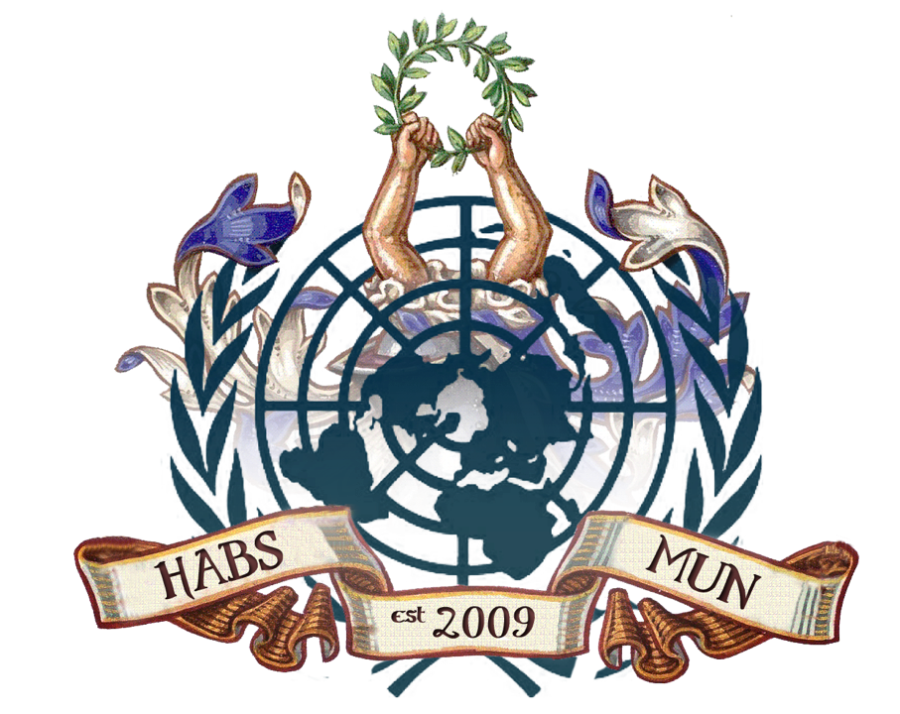

HABSMUN 2020
health briefing Paper
The Question of Antibiotic Resistance

Background
Antibiotics are a type of medicine used to prevent and treat bacterial infections. Antibiotic resistance happens when bacteria mutates as a reaction to the overuse of these medicines. This results in the antibiotics used to treat the bacteria, becoming less effective or completely futile allowing diseases to become almost incurable. It is one of the biggest public health issues of our time, causing more than 2 million infections and 23,000 deaths in the US alone.
Key Issues
Emergence of untreatable diseases
The overuse of antibiotics causes the emergence of superbugs which are strains of bacteria that have developed resistance to antibiotics such as MRSA and the bacteria causing tuberculosis. Diseases such as pneumonia, gonorrhea and salmonella have become harder to treat resulting in disability and death internationally. Furthermore, with the declining effectiveness of antibiotics, there are now longer hospital stays and higher medical costs, decreasing the provision of the healthcare system.
The Easy Accessibility of Antibiotics
One of the reasons as to why there is increased antibiotic resistance is the overuse of antibiotics due to how easy it is to purchase them. Antibiotics can be bought for human or animal use without a prescription and countries without standard treatment guidelines frequently overprescribe antibiotics, exposing more bacteria to antibiotics and allowing them to develop resistance.
Behaviour of Individuals
Certain actions can increase the chance of infection which results in more bacteria being exposed to antibiotics and hence, generating a resistance towards them. These include undercooking food in unhygienic environments, unsafe sex, using outdated vaccines and remaining in close contact with sick people. Moreover, individuals unnecessarily consume antibiotics when eating foods that have been produced with antibiotics due to famers using antibiotics frequently for growth promotion and prevention of diseases in animals.
Timeline of Key Events
1928-Sir Alexander Fleming discovers penicillin
1940-Report of first penicillin-resistance in E.coli
2009-Vaccine developed against Salmonella
2011-Smartphone app developed to guide antibiotic prescribing
2013- Whole-genome sequencing used to analyse how C.difficle infection spreads
2014- Antimicrobial resistance initiative launched, which involved the coordination of medical researchers, biologists, engineers, vets etc. in order to combat antibiotic resistance
Relevant Stakeholders
Biotechnology and Biological Sciences Research Council (BBSRC)- an agency that invests in bioscience research in the UK with the aims of combatting antibiotic resistance through research and producing strategies to combat this issue
World Health Organisation (WHO)-an organisation that regulates international health within the United Nations, they have set up various organisations that support the sharing and analysis of data related to antibiotic resistance such as ‘The Global Antibiotic Research and Development Partnership’ and ‘The Global Antimicrobial Resistance Surveillance System’
BMJ Global Health-an organisations that supports global health with particular management in areas that receive less financial aid for non-communicable diseases (NCDs), they re-evaluate and re-examine policies that are used to tackle antibiotic resistance.
Previous Measures to combat the issue
- World Health Organisation (WHO) enforced a ‘Global action plan on antimicrobial resistance’ with objectives including strengthening surveillance and research and reducing the incidence of infection
- The creation of ‘World Antibiotics Awareness Week’ which is held every November since 2015 with the intention of changing people’s careless behaviours that increase antibiotic resistance by explaining that one should think more carefully about whether it is necessary that they take antibiotics immediately after an illness arises
- Interagency Coordination Group on Antimicrobial Resistance (IACG) was established by the United Nations’ Secretary General to advance communication between international organizations and enforce adequate global action to combat this issue so that ideas of new and more effective treatments can be developed. It also allows for this issue to be tackled globally so that more countries have a better chance of protecting their citizens against antibiotic resistance
- Global Antibiotic Research and Development Partnership (GARDP) which is a partnership between WHO and Drugs for Neglected Diseases initiative (DNDi) encourages the research and advancement of antibiotics and aims to create up to 4 new treatments
- Medical Organisations are more cautious about using antibiotics, for example the NHS no longer routinely use antibiotics to treat chest infections, ear infections and sore throats

Questions to consider
- Limiting the use of antibiotics so that it is only taken when necessary. According to the Centres for Disease Control and Prevention, one-third to one-half of antibiotic use in humans is not required, unnecessarily increasing the chances of bacteria developing resistance to antibiotics. Furthermore, how can the prescription of antibiotics be monitored in areas where knowledge and awareness about the dangers of antibiotics are not as advanced.
- The behaviour of individuals to prevent infections that constantly need antibiotics. Whilst organisations may be discovering and developing new treatments if the behaviour of individuals does not change permanently then new antibiotics will become ineffective quicker, leaving us in a world where common infection and minor injuries can kill.
- The promotion of the investment in research and development of new antibiotics. One of the ways we can combat this issue is finding new antibiotics that can kill the bacteria that have become resistant to the antibiotics that are currently being used. Therefore, it is imperative that technology is used to discover alternative routes for diagnosis and treatments in order to be able to still treat common infections and diseases.

The Question of Genetic Modification

Background
Genetically Modified Organisms (GMOs) are being made by inserting a gene from an external source such as viruses, bacteria, animals or plants into usually unrelated species. Genetic modification brings with it a raft of issues ranging from ethical issues to questions of intellectual property rights (IPRs), as well as the role of governments in regulating this process. Animal welfare has been seen to be defined by the World Health Organisation (WHO) as: “the state of the animal…how an animal is coping with the conditions in which it lives”. Furthermore, the issue surrounding gene editing can be seen to be of great significance, especially in relation to human embryos.
Key Issues
Gene editing:
‘Embryo modification is unnatural, or amounts to playing God’. This argument rests on the premise that natural is inherently good. But diseases are natural, and humans by the millions fall ill and die prematurely—all perfectly naturally. If we protected natural creatures and natural phenomena simply because they are natural, we would not be able to use antibiotics to kill bacteria or otherwise practice medicine, or combat drought, famine, or pestilence. The health care systems maintained by many developed nations can be seen as an attempt to frustrate nature. Natural substances or natural therapies are only better that unnatural ones if the evidence supports such a conclusion.
However, it can also be seen that germ-line gene editing would not treat any existing person’s medical needs. At best, supporters can say that it might re-weight the genetic lottery in favour of different outcomes for future people. However, the unknown mechanisms of both CRISPR and human biology suggest that unforeseeable outcomes are almost definitely inevitable, providing key arguments against the use of gene editing tools.
Genetically Modified (GM) Food:
GM food, in particular crops can be seen to be a significant benefit to a world where food scarcity is increasingly a pertinent issue. This is as GM crops can be seen to be made more resistant to certain diseases, thus limiting the ability for diseases leading to famine to take hold.
However, it has been mooted that it could pose risks to those with allergies.

Timeline of Key Events
Relevant Stakeholders
- The European Consumer Organisation (BEUC)- an umbrella consumers' group, founded in 1962. Based in Brussels, Belgium, it brings together 45 European consumer organisations from 32 countries (EU, EEA and applicant countries), representing its members and defends the interests of consumers in the decision process of the Institutions of the European Union.
- European Environmental Bureau (EEB)- a democratic federation speaking on behalf of millions of EU citizens, which plays a prominent role in defending and promoting the environmental interests and legislation at the different EU institutions.
- GeneWatchUK- monitors developments in genetic technologies from a public interest, human rights, environmental protection and animal welfare perspective.
Previous Measures to combat the issue
- The primary purpose of the UK’s legislation and policy approach is the protection of people and the environment. Specifically, the government states that it will “only agree to the planting of GM crops, the release of other types of GM organism, or the marketing of GM food or feed products, if a robust risk assessment indicates that it is safe for people and the environment.” Each application for GM products is determined on a case-by-case basis, and includes consideration of all scientific information available, with the protection of public health and the environment being overriding priorities.
- National food-safety regulatory systems of countries that are party to the WTO must be consistent with principles established in the WTO Agreement on the Application of Sanitary and Phytosanitary Measures (SPS Agreement).2 The SPS Agreement governs measures to protect human, animal, or plant life or health, including food safety. While acknowledging the right of governments to enact such measures, the SPS Agreement also recognizes that such measures can operate as a de facto trade barrier and therefore sets out requirements to minimize trade barriers. Among other things, the SPS Agreement requires that measures be based on scientific principles and not maintained without scientific evidence except measures under Article 5 on which scientific information is insufficient.

Questions to consider
- Should genetically modified organisms (GMOs) be used to solve the issue of food security in Sub-Saharan Africa?
- How should the UN work to regulate the use of gene editing on human embryos?
- How should, if at all the UN work to protect the welfare of animals subject to be genetically modified?

The Question of Compulsory Vaccinations

Background
Non-communicable diseases can be viewed as the most significant threat to limiting the economic development of Less Economically Developed Countries (LEDCs). Furthermore, diseases such as measles can still be a threat to life in North America and Europe too. Vaccinations have been viewed as the primary tool to combat these diseases, yet many argue that to make vaccinations compulsory is to limit the freedoms and choices of individuals. Thus, this debate could be distilled to the liberty vs security debate, while also touching on cultural issues of vaccinations in areas including Sub-Saharan Africa.

Key Issues
- Increase current health inequities.
- Alienate parents.
- Enforcement issues.
  - Fines?
  - Withholdings state benefits?
  - Information campaigns.
  - Targeted catch-up programmes for those who had missed out on jabs.
  - Better reminders for parents when vaccinations were due.
  - Focusing efforts on areas where vaccination rates were particularly low.
- Regional variations within England. The vaccination rate in the North East was 94.5% in 2018-19, while in London it was just 83%.
  - London is seen by some as a special case as there is a more transient population, some with lower levels of knowledge of NHS community services than elsewhere.
- Too much government intervention- libertarian arguments.
- Issues regarding the creation of another level of bureaucracy to implement compulsory vaccinations.
- Issues regarding religious objections.

Timeline of Key Events
- 1796- Edward Jenner is considered the founder of vaccinology in the West, after he inoculated a 13 year-old-boy with vaccinia virus (cowpox), and demonstrated immunity to smallpox.
- 1798- the first smallpox vaccine was developed. Over the 18th and 19th centuries, systematic implementation of mass smallpox immunisation culminated in its global eradication in 1979.
- 1897 and 1904- Louis Pasteur’s experiments spearheaded the development of live attenuated cholera vaccine and inactivated anthrax vaccine in humans.
- Late 19th Century- Plague vaccine invented.
- 1890-1950- bacterial vaccine development proliferated, including the Bacillis-Calmette-Guerin (BCG) vaccination, which is still in use today.
- 1950-1985- viral tissue culture methods developed, leading to the advent of the Salk (inactivated) polio vaccine and the Sabin (live attenuated oral) polio vaccine. Mass polio immunisation has now eradicated the disease from many regions around the world.
- Late 1970s and 1980s- marked a period of increasing litigation and decreased profitability for vaccine manufacture, which led to a decline in the number of companies producing vaccines. The decline was arrested in part by the implementation of the National Vaccine Injury Compensation programme in the US in 1986. The legacy of this era lives on to the present day in supply crises and continued media efforts by a growing vociferous anti-vaccination lobby.
- The future will see the development of new vaccine delivery systems (e.g. DNA vaccines, viral vectors, plant vaccines and topical formulations), new adjuvants, the development of more effective tuberculosis vaccines, and vaccines against cytomegalovirus (CMV), herpes simplex virus (HSV), respiratory syncytial virus (RSV), staphylococcal disease, streptococcal disease, pandemic influenza, shigella, HIV and schistosomiasis among others. Therapeutic vaccines may also soon be available for allergies, autoimmune diseases and addictions.
Relevant Stakeholders
- Global agencies- agencies such as WHO, UNICEF, the World Bank, regional development banks and the GAVI Alliance, should do the following:
    - Advocate for and provide technical support to promote country ownership.
    - Strengthen national capabilities and regional infrastructure.
    - Continue to define norms and guidelines to improve vaccine and immunization services, striving to achieve greater equity and sensitivity to gender and subpopulation (including, among others, minorities and age groups).
    - Promote synergies between immunization and other health services as well with other sectors such as, education, economic development and financing.
    - Fund the provision of vaccines and immunization-related activities.
    - Work with all stakeholders to improve technical assistance to strengthen immunization and other components of health systems.
    - Encourage, share and support evidence-based decision-making across the spectrum of development, health and immunization stakeholders.

- Governments- as the main provider of immuization, governments should do the following:
    - Increase support for national immunization programmes and ensure financial sustainability by 2020.
    - Depending upon countries’ income and as economies grow, fund an increasing proportion of domestic immunization programmes, progressing to the full funding of domestic programmes, and then funding global immunization efforts.
    - Develop and introduce laws, regulations, and policies that support immunization programmes and a secure, high-quality supply base, if necessary.

- Health professionals:
    - Provide high-quality immunization services and information on them.
    - Introduce vaccine educational courses on immunization at universities and institutions training health-care professionals as well as continuing education for all health-care providers (medical, nursing, pharmacy and public health practitioners).

Previous Measures to combat the issue
- Every State in the United States requires children to be vaccinated before attending school, as do three Canadian provinces. Most states allow for medical, religious and philosophical exemptions but Mississippi and West Virginia have taken their policy a step further and only allowed for medical exemptions. A correlation has been seen between the ease with which exemptions are granted and the exemption rates, with studies showing a link between the eye of exemption and disease prevalence rates (www.ncbi.nlm.nih.gov/pmc/articles/PMC1446650/pdf/11291383.pdf)
- Other countries, such as Australia, offer financial incentives to boost compliance rates. Parents receive nontaxable payments of A$129 for each child who meets immunization requirements between 18 and 24 months of age, and again if the child meets requirements between four and five years of age.
- Slovenia has one of the world’s most aggressive and comprehensive vaccination programs. Its program is mandatory for nine designated diseases. Within the first three months of life, infants must be vaccinated for tuberculosis, tetanus, polio, pertussis, and Haemophilus influenza type B. Within 18 months, vaccines are required for measles, mumps and rubella, and finally, before a child starts school, the child must be vaccinated for hepatitis B.
- While a medical exemption request can be submitted to a committee, such an application for reasons of religion or conscience wouldn’t be acceptable, and isn’t allowed, says Alenka Kraigher, head of the communicable diseases and environmental health center at Slovenia’s National Institute of Public Health.
- Failure to comply results in a fine and compliance rates top 95%, Kraigher says, adding that for nonmandatory vaccines, such as the one for human papilloma virus, coverage is below 50%.

Questions to consider
- Providing concise clarification to key stakeholders including parents of children surrounding the risks of vaccination in order to increase uptake levels in key countries. Further, how supranational organisations aim to create policy on a global level which will act effectively on a local scale in order to remove stigmas and taboos surrounding vaccination.
- Preserving freedom of choice while ensuring high levels of uptake. Liberal values of freedom of choice are highly significant in western European culture, yet how does the government manage the relationship between preserving freedom of choice while protecting its population from key diseases?
- What measures should exist to guide governments relationships with pharmaceutical corporations when considering which vaccines should be promoted by the government in the future in order to adapt government policy to new diseases and risks?

https://www.ncbi.nlm.nih.gov/pmc/articles/PMC3558185/
World Health Organisation (OIE) Definition of animal welfare, glossary. 2010. Terrestrial Animal Health Code; p. xiv.
Should Gene Editing Be Performed on Human Embryos? John Harris and Marcy Darnovsky
http://sitn.hms.harvard.edu/flash/2015/from-corgis-to-corn-a-brief-look-at-the-long-history-of-gmo-technology/
https://www.bbc.co.uk/news/uk-scotland-49881317
https://www.immune.org.nz/vaccines/vaccine-development/brief-history-vaccination
Walkinshaw, Erin. “Mandatory vaccinations: The international landscape.” CMAJ : Canadian Medical Association journal = journal de l'Association medicale canadienne vol. 183,16 (2011): E1167-8. doi:10.1503/cmaj.109-3993

