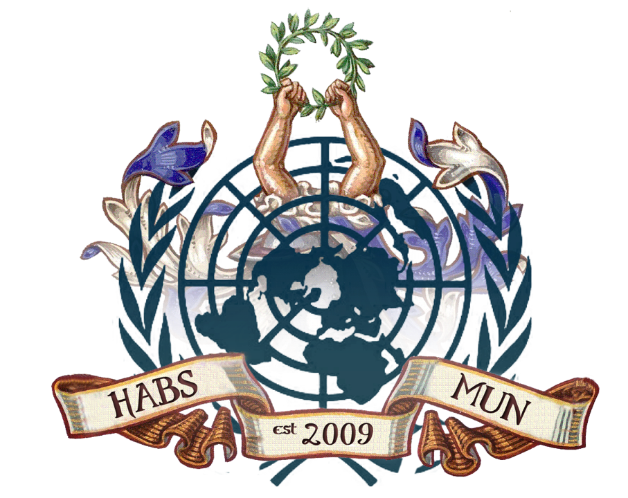

HABSMUN 2020
security council briefing Paper

The Question of Iran

Background
Since 1970, Iran has been working on and developing nuclear technology, claiming that it is only for electricity generation. This has caused serious concern for many countries, knowing that Iran could create nuclear weapons. Iran has also been very open about threatening other nations, namely Israel, which is another serious concern. To control this situation, countries have jointly imposed many sanctions to try and deter Iran, which have failed to succeed. Finally, in 2015, an agreement was reached between Iran and the P5+1 (United Kingdom, France, Germany, Russia, China and United States) called the Joint Comprehensive Plan of Action (JCPOA) or the Iran nuclear deal framework. Within this deal, it was decided that Iran would be limited in its nuclear facilities, it’s number of centrifuges (for ten years, Iran would have to place over two-thirds of its centrifuges in storage) and the amount of enriched uranium they could possess (Iran’s stockpile of low-enriched uranium would be reduced by 97% from 10,000 kg to 300kg for 15 years). Another term stated that Iran would be allowed to continue research and development on the enrichment of uranium but this could only take place in certain facilities (namely the Natanz facility) however this would include certain limitation for the first eight years. Iran also had to agree to the regular monitoring of this by the International Atomic Energy Agency (IAEA). The number of IAEA inspectors assigned to Iran would therefore triple from fifty to one hundred and fifty inspectors. In return, all nuclear-related economic sanctions would be lifted.

Since then, there has been some dispute about Iran’s adherence to the deal and the IAEA has discovered that Iran has violated this agreement and exceeded their limit of enriched uranium. In May 2018, President Trump withdrew the US from the JCPOA due to the belief that the terms of the deal were not harsh enough on Iran as many of the terms expire in the next 10-15 years, allowing Iran to return to possessing sufficient nuclear technology to make nuclear weapons. The US reimposed many of their nuclear-related economic sanctions, including ending a waiver that allowed countries to import Iranian oil. These sanctions have had a severe impact on Iran’s economy, and it is predicted that it’s GDP will decline by 9.5% in 2020. Inflation has increased, and the currency value and oil exports have decreased significantly in Iran. The UN chief called on other JCPOA participants to abide fully by the their respective commitments and all other Member States to support the agreement despite the US withdrawing. The EU’s chief diplomat Josep Borrell quoted “We have been saying in the past and we continue to say that we regret the US decision to withdraw from the deal.” He also warned that negotiating a new pact would be a “very complex, highly technical process” that would take a long time. Britain, France and Germany (three parties in the P5+1) have repeatedly stressed their commitment to saving the JCPOA even after Trump urged them to join him in walking away.

On January 5th, Iran announced that they would no longer adhere to the terms of the JCPOA and its amount of enriched uranium has increased drastically, showing significant steps towards creating a nuclear weapon. Some sources have said that Iran will agree to the terms of the JCPOA once more if sanctions are lifted.

Key Issues
Nuclear Weapons – Iran has the resources and ability to start creating nuclear weapons. They have recently stopped adhering to the terms of the JCPOA, so this is a very pressing issue.

The conflict between the USA and Iran – Recently, the countries have had a lot of problems, including Iran shooting down an American surveillance drone and later, the US assassinating an Iranian General.

Iran’s economy – It has been severely affected because the US have recently reimposed economic sanctions.

Timeline of Key Events
1970: Iran starts to develop nuclear technology

1979: Iranian Revolution (involving the seizure of the US embassy in Tehran thereby severing US-Iranian ties)

2003: IAEA adopt a resolution calling for Iran to suspend enrichment and to declare all materials relevant to its uranium-enrichment program, Iran agrees

2004: Iran fails to cooperate

2006: The UN security council unanimously adopts Resolution 1737, imposing sanctions on Iran for its failure to suspend enrichment-related activities

2015: Creation of the Joint Comprehensive Plan of Action (JCPOA)

2018: US withdraws from the JCPOA and reimposes sanctions on Iran

2020: Iran announces that it will no longer adhere to the JCPOA

Relevant Stakeholders
The United States of America – The US plays an extremely important role as they withdrew from the JCPOA and reimposed sanctions on Iran.

Iran – Iran has been very open about threatening other nations, and with the expansion of their nuclear technology, this is a very serious problem.

UK, France, Germany, China & Russia - except for Germany, they are all permanent members of the UN Security Council and also all members of the P5+1.

IAEA – This is an International agency that has been monitoring Iran to ensure that they have adhered to the JCPOA.

Previous Measures to combat the issue
IAEA resolutions – In 2003, the IAEA attempted to make a deal with Iran, and although Iran agreed, a year later, they failed to cooperate.

Resolution 1737 – This resolution imposes sanctions on Iran, and it also makes Iran’s activities of enriching uranium illegal for the first time.

JCPOA – This was the most successful measure to date, yet, it still didn’t properly combat this issue. Iran, although it was not meeting every standard set by the IAEA, was still meeting most of its requirements and was heavily reducing its the number of centrifuges and enriched uranium. This however changed when the US reimposed their sanctions.

Questions to consider
- Why the JCPOA (and other previous measures to combat the issue) failed – Even before the US withdrew from this agreement, the IAEA found that Iran had violated some terms of the JCPOA. Also, it contained many ‘sunset provisions’ meaning that many of the agreements would expire in the next 10-15 years, so this agreement therefore wasn’t effective in the long term.

- How to create a new agreement that will prevent a further dispute between the US and Iran – This is an important question and mustn’t be overlooked. If another agreement is made and the US withdraw again, Iran will return to making nuclear weapons and no progress will be made.

- How to permanently ensure Iran’s nuclear technology is not used militarily – The creation of nuclear weapons will have a drastic affect on the rest of the world due to constant threats and possibly a war.

- How to prevent Iran from carrying out their threats on other nations – There is a significant conflict between Iran and Israel and measures need to be taken to prevent this from worsening.

- How to deter Iran from obtaining nuclear weapons – This must be the focus of the new agreement that is created and it must include both long term solutions to prevent Iran from accessing nuclear technology and also focus on Iran’s relations with other countries.

Useful Links

https://www.businessinsider.com/iran-nuclear-deal-explained/?r=AU&IR=T

https://www.bbc.com/news/world-middle-east-51008661

https://www.cfr.org/backgrounder/what-status-iran-nuclear-agreement

https://www.euractiv.com/section/global-europe/news/eu-willing-to-maintain-iran-nuclear-deal-risking-rift-with-the-us/

The Question of the Israel Palestine Conflict
Background
At the end of WW2 with the horrific memory of the Holocaust still fresh in the minds of millions of Jewish people there was mass migration to the area at the time known at Palestine. Historical areas such as Jerusalem were particularly popular for migration, as it was seen as a historically significant area for the Jewish homeland. With the complex history of the land in mind UN GA Resolution 181 was adopted in 1947, calling for the separation of Arab and Jewish states. Following this in May 1948 Israel declared Independence, and the next day Syria, Jordan, Lebanon and Egypt attempted to invade. This started the large Palestinian refugee crisis after Israel took land that was reserved for Arab Palestinians only. Fighting and terrorism ensued following this crisis, resulting in millions suffering in conflict.
Both sides have attempted to end the conflict, most famously the Oslo Accords in 1993 saw Palestinian and Israeli leaders try to negotiate peace. In these accords, Palestinian Authorities were recognised, and this commenced years of diplomatic efforts to resolve the conflict. Currently, Prime Minister Netanyahu and President Abbas lead the peace negotiations. However, Netanyahu faces his own political pressures within Israel and President Abbas is the leader in Palestine, but there is another group named Hamas who control the Gaza Strip.
The heightened nature of the conflict means that the support of the international community is needed to progress the peace talks. This includes the United States, European Union, Russian Federation, United Nations and Arab League.

Key Issues
Right of Return – After the 1948 war, over ten-thousand people fled their homes, this led to millions of Palestinians living in refugee camps. And according to the Global Policy of the “Israel-Palestine and the Occupied Territories” the refugees assert they have a right “to citizenship, financial settlement and, in some cases, return to former homes and property in what is today Israel”. None-the-less, the Israeli authority oppose this right as they wish to keep the state as Jewish.
National Security – In order to secure their borders the Israeli military occupy sections of Palestine that were seized during the Arab-Israeli wars. This leads to a cycle of tensions and conflict between both sides. Palestinian groups have fired rockets into Israeli territory and the United States recognise Hamas (a leading Palestinian group), as a terrorist organisation.
Border conflict – The two-state solution was proposed in 1948 following resolution 181, and since then, the overwhelming aim of the international community has been in support of this idea. However, with many wars since then and boundaries moving constantly there is much dispute as to where boundaries belong.
Timeline of Key Events
1919: 90,000 Jewish people arrived in Palestine
1919-1947: The number of Jewish immigrants in Palestine doubled
1947: UN calls for two separate states to be formed, this led to months of conflict where thousands of people were killed
1948: As the British mandate ended, Iraqi, Syrian, Jordanian, and Egyptian armies entered the region
1949: Refugee crisis commenced with the Gaza Strip and West Bank being sectioned into involved nations. Leaving 800,000 Jews expelled from Arab lands and 700,000 Palestinian Arabs blocked access to Israel
1967: Six days war commenced
1970: Jordan and Palestine began a conflict with each other. 70% of the Jordanian population were considered Palestinian refugees. Palestine were given autonomy over south Lebanon
1970: The PLO used violence against civilians when attempting to take over the the West Bank. They also played a role in the Lebanese civil war
1973: The Yom Kippur War began with a coordinated attack against Israel by the Egyptians and Syrians
1987: First Intifada – Palestinian riots raged across the West Bank and Gaza Strip. Hamas was created
1993: The Mehola Junction Bombing occurred (Hamas suicide attack in Israel). PLO and Israeli government started having secret peace-talks.
1994: Oslo Peace Process began
1995: Oslo 2 was signed laying out an agreement for the West Bank and Gaza
2000: Israel withdrew from Lebanon. Peace talks stalled
2000-2005: Second Intifada started
2003: ICJ affirmed that the West Bank barrier was not legal under international law
2006: In the Palestinian election, Hamas won the majority of seats. Violence broke out between Fatah and Hamas in the Gaza Strip
2008: Israel launched operation Cast Lead
2011: Palestine joined UNESCO
2015: Stabbing Intifada occurred
2017: Hamas gave control of Gaza back to the Palestinian Authority. President Trump moved the US embassy to Israel to Jerusalem recognising it as a capital city

Relevant Stakeholders
United States of America: The US and Israel have been in diplomatic relations since 1948 when the State of Israel was created. This is especially important as the Israeli Lobby is extremely powerful in the United States. Their aim is to help security in Israel and preserve the Peace Process that takes place with negotiations. Ex-US Secretary of State, John Kerry attempted to create a final agreement, however, he failed to propose anything more than an interim solution. His proposed solution aimed at forming a two-state solution. The US does not have any diplomatic relations with Palestine, considering that they recognise Hamas, the authorities in control of the Gaza strip as a Foreign Terrorist Organisation.
Arab League: It is an organisation that comprises Egypt, Iraq, Jordan, Lebanon, Syria and Saudi Arabia. The League has backed the peace process between Israel and Palestine, however, as tensions rose between Hamas and Israel throughout the Gaza Strip, the Arab league threatened to withdraw their recognition of Israel if the violence continued.
State of Israel: The area in which the conflict is currently occurring. They do not consider the West Bank as an ‘occupied territory’, instead, they see it as ‘disputed territory’. The Israeli Government suggest that the border disputes do not violate any Israeli-Palestinian Treaty
State of Palestine: They have observer status in the UN, and have not been recognised as an official state by many countries. They accept the right of Israel to exist, however, fail to accept it as a Jewish state. The West Bank is controlled by the Palestinian authorities, while Hamas control the Gaza Strip.
UNRWA: The United Nation body that is charged with relieving the situation in Palestine
PLO: Palestinian Liberation Organisation this group has represented the Palestinian People at a plethora of peace talks.

Previous Measures to combat the issue
Camp David Accords (1978): This was a peace negotiation that took place between Egypt and Israel. It sought to achieve peace, not only for the countries involved but the whole Middle East. An agreement was reached for Israel to gradually withdraw from the Sinai Peninsula, and to gain the right of passage for Israeli ships to travel through the Suez Canal. The accords were signed, ratified and were a diplomatic success.
Oslo Accords II (1995): These accords split up occupied territories into three areas. Area A was to be controlled entirely by the Palestinian Council. Area B would technically be under the authority of the Palestinian Council, however, under Israeli security control. Finally, Area C would be entirely ruled by the Israeli Government. However, these agreements were supposed to only be interim until a more long-lasting peace could be found.
2005 Disengagement Plan: This was a plan to disengage all settlements in the Gaza Strip and some in the West Bank in order to increase security of Israeli civilians and relieve a portion of the pressure that is on the Israeli Defence Forces (IDF). However, it has been criticised because of its lack of diplomacy in the negotiating process.

Questions to consider
- Refugee Crisis – One of the most overlooked issues within the conflict is the families that have been separated and displaced as part of the refugee crisis. This is worsened by the lack of citizenship held by many Palestinian refugees.
- Humanitarian Aid – Material aid such as water and food are needed in the area, as well as job prospects as unemployment is a large concern. This would develop the areas infrastructure. However, it needs to be closely overseen as it could be used by either side to incite increased violence in the area.
- Ending the Violence – This is the primary concern. Extremist attacks are common, and violence is occurring on both sides. Although negotiations are useful, a cease-fire may also be necessary to find neutral grounds for leaders to meet.
- Peace Talks – These are traditionally confusing and need to be focused on one of the following key areas in order to be resolved. These are (1) The Gaza blockade, (2) Israeli Security, (3) Palestinian Refugees, (4) West Bank Settlements and (5) Jerusalem.
- Palestine’s Legitimacy – As Palestine applies to be the 194th Member of the United Nations questions arise regarding the legitimacy and credibility of Palestine as a UN member. This is especially important as many countries fail to recognise Palestine as a legitimate state, including 19/28 EU member states.

