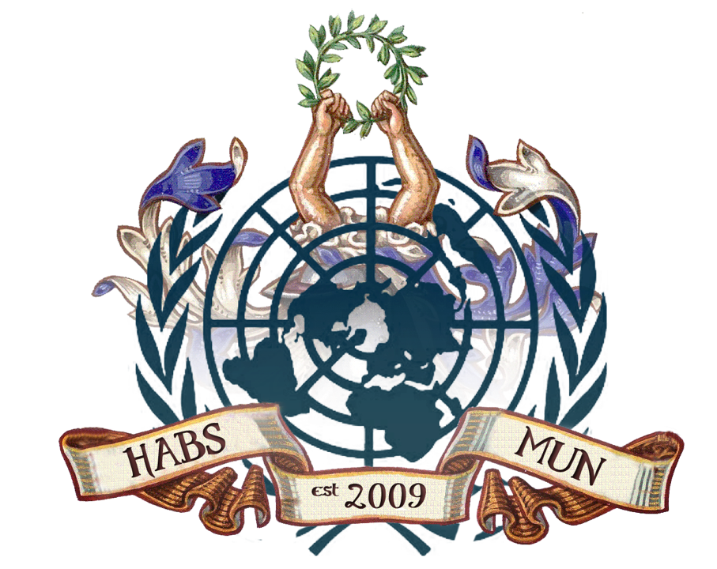

HABSMUN 2020
specpol 2 briefing Paper

THE QUESTION OF THE SOUTH CHINA SEA

Background
Rival countries have wrangled over territory in the South China Sea for centuries, but tension has steadily increased in recent years.
China, Vietnam, the Philippines, Taiwan, Malaysia and Brunei all have completing claims
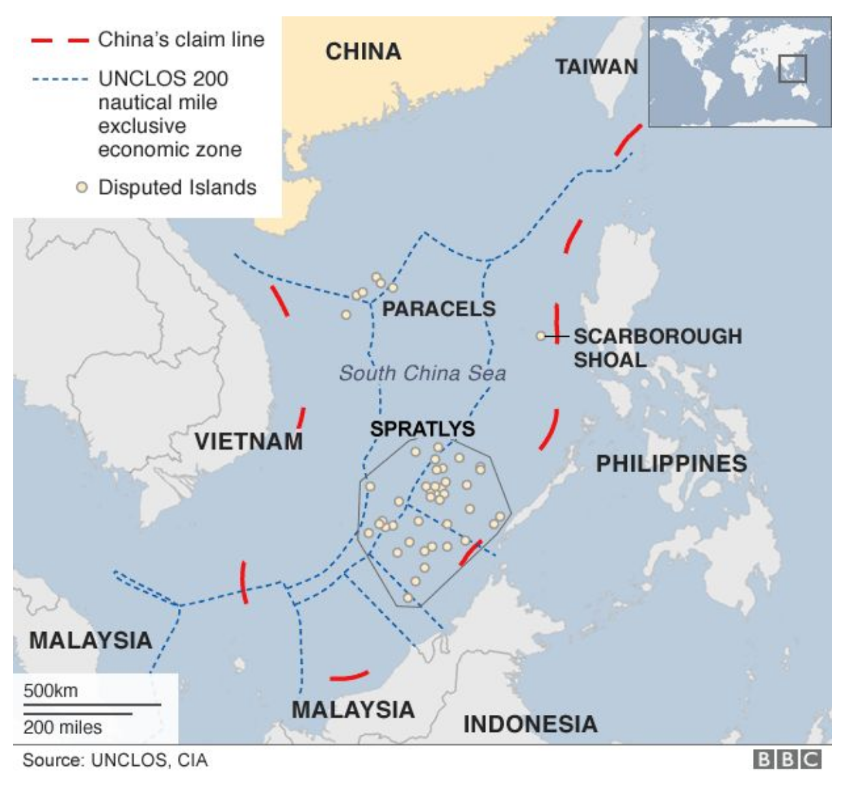
China has backed its claims with Naval Patrols and building artificial islands by depositing sands. The USA says it does not intervene in territorial disputes but has recently sent military ships and planes near the disputed territories, on “freedom of navigation” missions.

Key Issues
Control of the Spratly Islands
- China claims to control these Islands, based on a 1947 map. This is widely disputed
- Vietnam claims to have controlled the islands since the 17th century, with documents to prove it
- The Philippines also claims the area, due to its geographical proximity
- Malaysia and Brunei also claim to territory they say falls within their economic exclusion zones under UNCLOS (UN Convention on the Law of the Sea)
China’s land reclamation
- In recent years, satellite imagery has shown China’s increased efforts to reclaim land in the South China Sea by physically increasing the size of islands or creating new islands altogether.
- In addition to piling sand onto existing reefs, China has constructed ports, military installations, and airstrips—particularly in the Paracel and Spratly Islands, where it has twenty and seven outposts, respectively.
- This has been a source of tension as the USA has challenged these claims by bolstering support for Southeast Asian Partners and conducting “Freedom of Navigation” operations
American Involvement
- China’s actions have threatened American Sea Lines of communication (SLOCs). The USA has subsequently expressed support for an agreement on a binding code of conduct and other measures to build confidence
- Washington’s defence treaty with Manila could draw the USA into a potential territorial dispute or China-Philippines conflict
Timeline of Key Events
1947: China claims the Spratly islands on a map
1974: Chinese seized land from Vietnam, killing over 70 Vietnamese troops
1988: Another Chinese-Vietnamese skirmish, with 60 Vietnamese killed
2012: China and the Philippines engaged in a lengthy maritime standoff
2012: Large anti-china protests in Vietnam over unverified claims that the Chinese navy sabotaged two Vietnamese exploration operations in late 2012
January 2013: Manila said it was taking China to a UN tribunal under the auspices of the UN Convention on the Laws of the Sea
May 2014: China introduced a drilling rig into waters near the Paracel Islands, leading to multiple collisions between Vietnamese/Chinese ships

Relevant Stakeholders
The United Nations
The UN is important in this area to try to ensure that countries try to resolve the issue which has thus far failed. This is key to prevent a destabilizing arms buildup. Furthermore, the UNCLOS treaty is key in the area, with Malaysia and Brunei using it to claim the Spratly Islands.
Countries with claims in the South China Sea
Countries with claims in the area include China, the Philippines, Vietnam, Brunei and Malaysia. These countries will undeniably seek to gain control of as much territory as possible, given the strategic importance of these islands, and the abundance of natural resources in the area.
ASEAN
The Association of South East Asian Nations is a regional intergovernmental organisation in the area. Thus far, it has failed to come to a solution to the issue, and China has refused to engage with it. China is, crucially, not a member of ASEAN

Previous Measures to combat the issue
China prefers bilateral negotiations. However, many countries argue these are unfair due to China’s superior bargaining power
Some countries have argued that China should negotiate with ASEAN, although China opposes this, and ASEAN is divided over the solution to the issue.
The Philippines has sought international arbitration, taking China to a UN tribunal under the auspices of the UN Convention on the Laws of the Sea in 2013. In July 2016, the tribunal backed the Philippines' case, saying China had violated the Philippines' sovereign rights. China had boycotted the proceedings, and called the ruling "ill-founded". It says it will not be bound by it.
Questions to consider
- Should China be reprimanded for its actions of land reclamation?
- How can conflict be minimized?
- How can a diplomatic route forward be found to prevent destabilizing conflict?
- How can lucrative resources be allocated in the area?
- How can potential US involvement be avoided?

THE QUESTION OF THE GLOBAL POPULIST SURGE

Background

Populism is arguably on the rise around the world, referring to figures such as Donald Trump, Jeremy Corbyn and Rodrigo Duerte. These people have all been defined as populists.1

Populism generally refers to figures in politics who supposedly represent the “will of the people” against the established elite.

Populist parties can be anywhere on the political spectrum, with examples on the right, such as Marine Le Pen, who combines populism with anti‐immigrant ideals, and the left, such as the late Venezuelan president Hugo Chavez.2

Key Issues

Some argue that populism is a threat to democracy, arguing that the will of the people is not always a clear cut thing, and democracy is not always about simply enacting what the people say. Former British Prime Minister Tony Blair declared that “the modus operandi of populism is not to reason but to roar”.3

Furthermore, populist movements can often be divisive among their members, with controversial figures such as Marine Le Pen and Ukranian President Viktor Orban being examples of prominent and divisive populist figures.

This is not a problem limited to the right, with many left wing populist parties left unable to enact the populist policies they suggest. A prominent example is the Greek Syriza Party, who have been left unable to implement the policies they won the 2015 election on.

Timeline of Key Events

‐ 1840s: Emergence of the Know Nothings. This was a political party in the USA, that
emerged in reaction to mass immigration to American Cities.4
‐ 1880s: Left‐wing populism emerges in the USA, who formed the Peoples’ Party, also
known as the populists. This was in response to farmers suffering due to falling cotton

1 BBC News, What is populism, and what does the term actually mean?, available online:
https://www.bbc.co.uk/news/world‐43301423
2 BBC News, What is populism, and what does the term actually mean?, available online: https://www.bbc.co.uk/news/world‐43301423
3 New York Times, Tony Blair: Against Populism, the Center Must Hold, available online: https://www.nytimes.com/2017/03/03/opinion/tony‐blair‐against‐populism‐the‐center‐must‐ hold.html?_r=0
4 The Week, A brief history of populism, available online:
prices and drought in the Southern USA. Many of their ideas were absorbed by the Democrat party.
‐ 2008: Global financial crisis. The 2008 financial crisis sparked anger among many
against Wall Street and Washington, who were perceived to have caused the crisis or at the very least not seen it coming. This manifested itself in movements such as “Occupy Wall Street”
‐ 2011: “Occupy Wall Street” protest movement emerges. This group protested against
economic inequality in New York, with their slogan “We are the 99%”, referring to wealth inequality in the USA.5
‐ 2016: The UK votes to leave the European Union in June and Donald Trump is elected
President of the USA in November.

Previous Measures to combat the issue

‐ At a labour party conference, centre left leaders from across the world gathered to
discuss how to combat populism, and agree on needing to ‘re‐engage with the public, address their fears, and take the fight for extremist parties’

‐ The creation of Agenda 2030, which contains the Sustainable Development Goals‐ by
having these goals in place we can counter the often radical views of populism by providing world leaders with goals which they also believe in‐ but on a less extreme scale

Questions to consider

Delegates should consider how sustain a UN which can provide multilateral solutions to global political issues without being seen as controlling separate countries and infringing on national sovereignty

Delegates should also consider how to tackle the rise in populism, whether it be through changing economic or political policies within nations

How to ensure populism doesn’t lead to political parties’ views becoming extreme and therefore nations developing with radical views

5 Occupy wall street website. Available online: http://occupywallst.org/
3

4
THE QUESTION OF THE ROHINGYA PEOPLES

Background
The Rohingya are a group of Muslims who were living in predominantly buddhist Myanmar, predominantly in the Rakhine state. At the start of 2017, there were around 1 million Rohingya living there, but in August that year, the Myanmese government began one of the most deadly genocides known to date. The exclusion and eventual attempted ethnic cleansing upon the Rohingya began in 2014, when Myanmar conducted a nationwide census, but excluded the Rohingya. The following year, Rohingya weren't allowed to vote, and a power sharing government between the Prime Minister and the military was formed.

Key Issues
The real height of the crisis began when in August 2017, after a few Rohingya men killed 12 security officers, the military began 'clearance operations' of the Rohingya, which entailed the mass burning of villages, killing of civilians and the raping and abuse of women. Over the next few months over half a million Rohingya left, the majority seeking refuge in neighbouring Bangladesh, in camps in the Cox bazar region with little access to basic necessities such as food and water, and with poor hygiene standards- leading to events such as the diphtheria outbreak in the camps in 2018. 32,000 of these refugees in Bangladesh are registered there, and are part of a plan given by Bangladesh's prime minister, Sheikh Hasina, to relocate them, but there are several hundred thousand more living there undocumented who won't receive any such help. In 2019, OCHA (United Nations Office for the Coordination of Human Affairs) launched a Joint Response Plan, requesting $920 million from nations across the world, to provide to the now 1.2 million Rohingya refugees in Bangladesh and other countries such as The Philippines, Thailand and Indonesia.

Previous Measures to combat the issue
The other issue is that the Rohingya people aren't able to uphold their rights because Myanmar don't accept them as their citizens, effectively making these people stateless. In November 2019, The Gambia filed a case against Myanmar in the ICJ on behalf of the Rohingya, for the ethnic cleansing of over a million people. Additionally in November, the UN international criminal court began a full investigation into the crimes committed by the Myanmar authorities. Altho the UN criminal court don't have any jurisdiction in Myanmar, as its not part of the Roman Satue (a treaty signed which allows the UN to investigate 4 core crimes, one of which is genocide, when a country is unable to or unwilling to do so themselves), Bangladesh is, which is where most of the Rohingya are currently living. Myanmar denies all such allegations of genocide and human rights abuse against the Rohingya, and their prime minister, Suu Kyi, also remained silent and hasn't stepped in to stop the military's actions.

Questions to consider
- Delegates should consider how to safely house and feed over a million refugees when these aren't actually the responsibility of the Myanmar government because they don't count them as their citizens
- Delegates should also consider the outcome of the case in the ICJ against Myanmar and the consequences they will face if convicted of genocide, and how to facilitate the Rohingya to return to their country with the full support and cooperation of the government.
- So far the UN haven't taken any significant steps in order to combat this issue- so how should the UN intervene in order to give justice to the Rohingya and also prosecute the various members of the government involved in this genocide

BBC News, Why is the South China Sea contentious? Available online: https://www.bbc.co.uk/news/world-asia-pacific-13748349
BBC News, Why is the South China Sea contentious? Available online: https://www.bbc.co.uk/news/world-asia-pacific-13748349
Global conflict tracker, Territorial disputes in the South China Sea, Available online: https://www.cfr.org/interactive/global-conflict-tracker/conflict/territorial-disputes-south-china-sea
Global conflict tracker, Territorial disputes in the South China Sea, Available online: https://www.cfr.org/interactive/global-conflict-tracker/conflict/territorial-disputes-south-china-sea
BBC News, Why is the South China Sea contentious? Available online: https://www.bbc.co.uk/news/world-asia-pacific-13748349

